THE ORAL ANTICOAGULATION TREATMENT IN ELDERLY PATIENTS WITH PERMANENT ATRIAL FIBRILLATION

Dana Munteanu¹, Ana-Maria Vintilă¹, Minerva Muraru^{1,2}, Dan Isacoff ^{1,2}, Ion Bruckner^{1,2}
¹Internal Medicine and Cardiology Department, Colţea Hospital
² Carol Davila University of Medicine and Pharmacy
dr.dana.munteanu@gmail.com

Abstract
Background. Atrial fibrillation is the most common sustained cardiac arrhythmia and it is associated with a risk of thromboembolism of 4 % in patients over 75 years with a poor prognosis of stroke and mortality, especially among patients with associated risk factors. In the present work, we assumed that oral anticoagulant therapy in elderly patients with nonvalvular atrial fibrillation is an issue with important practical applications and that this therapy was a matter of controversy over time.
Aim of study. In the present work, we proposed to observe how the oral anticoagulation treatment is implemented in the medical practice in elderly patients with atrial fibrillation in order to identify the problems encountered by it and to find solutions for optimizing the treatment in the future.
Methods. Retrospective study made of 256 patients with permanent atrial fibrillation, age over 65 years old. For each patient were calculated the stroke risk score (CHA2DS2Vasc) and the bleeding risk score (HAS-BLED) according to ESC Guidelines for the management of atrial fibrillation 2010 and the efficacy of the oral anticoagulation treatment has been monitored by the INR value, with a INR value between 2 and 3 as a treatment’s target.
Results. All patients, but one had indication for oral anticoagulation (CHA2Ds2VAScscore ≥2). However, only 113 patients were under oral anticoagulation because either they declared that they cannot monitor the INR either after o period of monitoring the INR it has been found that they were not compliant to treatment, or due to the impaired of the digestive tract.
Regarding the efficacy of the treatment, approximately half of the patients with age over 75 had the INR value under 2. Women were more frequent overdosed in comparison with man (p= 0.031). Among the patients whom were undergoing the oral anticoagulation treatment, 10 came with obvious bleeding, with an average stroke risk score of 3.8 comparison with a 2.82 score in those without bleedings (p= 0.001).
Conclusions. Oral anticoagulation treatment is prescribed more carefully in elderly people than in general population. Almost half of the patients were under sub-optimal oral anticoagulation. The impossibility of monitoring the INR represents the main barrier regarding the oral anticoagulation in these patients. We can easily rely on a bleeding risk score of 3 in order for us to administrate oral anticoagulation treatment, regardless the patient’s age.
Keywords: atrial fibrillation, oral anticoagulation treatment, INR.

Rezumat
Introducere. Fibrilația atrială este cea mai frecventă aritmie cardiacă susținută și se asociază cu un risc de trombembolism de 4% la pacienții cu vârsta de peste 75 de ani, care au un prognostic prost pentru accidentul vascular cerebral (AVC) și mortalitate, în special când prezintă factori de risc asociați. În prezenta lucrare, am pornit de la premisa că terapia anticoagulantă, la pacienții vârstnici cu fibrilație atrială nonvalvulară este un subiect cu multiple aplicații practice importante și că această terapie a reprezentat subiect de controversă de-a lungul timpului.
Scopul studiului. În prezenta lucrare, ne-am propus să observăm modul în care este implementată terapia anticoagulantă orală în practica medicală, la pacienții vârstnici cu fibrilație atrială, cu scopul de a identifica problemele întâlnite și de a găsi soluții pentru optimizarea tratamentului în viitor.
Metodă. Am realizat un studiu retrospectiv, care a inclus 256 de pacienți cu fibrilație atrială permanentă, cu vârsta de peste 65 de ani. Pentru fiecare pacient, au fost calculate scorul de risc pentru AVC (CHA2DS2Vasc) și scorul de risc pentru sângerare (HAS-BLED) conform Ghidului ESC pentru Managementul Fibrilației Atriale din anul 2010, iar eficiența tratamentului anticoagulant oral a fost monitorizată prin valoarea INR, cu o valoare țintă a acestuia cuprinsă între 2 și 3.
Rezultate. Toți pacienții, cu excepția unuia aveau indicație pentru terapie anticoagulantă orală (CHA2Ds2VAScscore ≥2). Totuși, numai 113 pacienți se aflau sub terapie anticoagulantă, fie din cauză că au declarat că nu-și pot monitoriza INR-ul, fie pentru că, după o perioadă de monitorizare a INR-ului, s-a constatat că nu erau complianți la terapie, sau din cauza riscului de complicații digestive.
Cu privire la eficiența tratamentului, aproximativ jumătate din pacienții cu vârsta de peste 75 de ani aveau valorile INR-ului sub 2. Femeile erau mai frecvent supradozate decât bărbații (p =0,031). În rândul pacienților care primeau terapie anticoagulantă orală, 10 s-au prezentat cu sângerare evidentă, cu un risc de AVC mediu de 3,8, comparativ cu un risc de 2,82 la pacienții fără sângerări (p =0,001).
Concluzii. Terapia anticoagulantă orală este prescrisă cu mai mare precauție la pacienții vârstnici decât în populația generală. Aproape jumătate din pacienți primeau anticoagulare suboptimală. Imposibilitatea monitorizării INR-ului reprezintă principala barieră în calea anticoagulării acestor pacienți. Ne putem baza cu ușurință pe un scor de risc al sângerării cu valoarea 3, pentru a administra terapia anticoagulantă orală, indiferent de vârsta pacientului.
Cuvinte cheie: fibrilația atrială, terapia anticoagulantă orală, INR.

Introduction

Atrial fibrillation (AF) is the most common sustained cardiac arrhythmia occurring in 1–2 % of the general population. The prevalence of AF increases with age, from 10 % at 80 years, to over 18 % at 85 years⁽⁹⁻¹⁰⁾. In the next 50 years to come, the prevalence of AF is expected to double, with the population aging⁽¹⁾.
The atrial fibrillation is associated with increased rates of death, stroke and other thrombo-embolic events. The risk of thromboembolism is at least 4 % in patients over 75 years, with a poor prognosis on stroke and death, especially in patients with associated risk factors⁽¹⁾.
The current literature on atrial fibrillation’s management sustain that⁽¹⁾ stroke’s incidence is significantly reduced by oral anticoagulation, with a maxim effect on INR values of 2 – 3. Taking into fact this standard, the risks of the oral anticoagulant therapy are acceptable, with a risk – benefit ratio net positive for benefit⁽⁷⁾.
A correct management of patients with atrial fibrillation reduces the symptoms and prevents the occurring of complications, which will decrease the number of hospitalizations by improving the quality of life for these patients⁽³⁾.
In medical practice, regarding the management of atrial fibrillations we encounter the following obstacle: whether to initiate or maintain an oral anticoagulation therapy or not, especially in elderly patients. The oral anticoagulation has been and still constitutes an issue.
Guidelines for management of atrial fibrillation by European Society of Cardiology 2010⁽¹⁾tries to clarify this problem, introducing on one hand new factors involved in choosing the anticoagulation therapy and on the other hand tries to quantify the bleeding risk by introducing the bleeding risk score.
Thus, ESC Guidelines for management of atrial fibrillation⁽¹⁾ proposes assessing stroke risk in patients with nonvalvular atrial fibrillation using a new score system CHA2DS2VASc⁽¹⁾ (Congestive heart failure, Hypertension, Age ≥75 (doubled), Diabetes, Stroke (doubled), Vascular disease, Age 65–74, and Sex category (female).
Unlike CHADS2score (Cardiac failure, Hypertension, Age, Diabetes, Stroke),CHA2DS2VASc score assigns 2 points for age ≥75 years and adds age between 65–75 years (1 point), vascular disease (myocardial infarction, complex aortic plaque, and PAD, including prior revascularization, amputation due to PAD, or angiographic evidence of PAD, etc.) (1 point) and female sex (1 point). A score with over 2 requires anticoagulation therapy if no contraindications⁽¹¹⁾.
In this context, we draw attention to the fact that all patients older than 75 with permanent atrial fibrillation have an indication for oral anticoagulation in the absence of contraindications, regardless of type and number of comorbidities.
An assessment of bleeding risk should be part of the patient assessment before starting anticoagulation, thus a new simple bleeding risk score has been introduced HAS-BLED (Hypertension, Abnormal renal/liver function, Stroke, Bleeding history or predisposition, Labile INR, Elderly (over 65 years), Drugs/alcohol), giving 1 point for each clinical characteristic, whereby a score of ≥3 indicates high risk of bleeding.

Aim of study

In this paper, we proposed to observe how the oral anticoagulation therapy is performed in elderly patients with atrial fibrillation, in order to identify the problems which may occur and to find potential solutions to optimize this therapy in the future.

Methods

Retrospective study made on 256 patients with permanent atrial fibrillation, age ≥65 years, hospitalized in Internal Medicine and Cardiology Departments, Colțea Hospital, between September 2009-September 2010. For each patient the stroke risk (CHA2DS2Vasc), respectively the bleeding risk score (HAS-BLED) were calculated, according to ESC Management Guidelines for atrial fibrillation (2010) and also the oral anticoagulation therapy effectiveness was monitored by INR values.
Has been considered as a therapy target an INR value of 2-3. Were investigated the reasons why the anticoagulation therapy was not initiated or was interrupted in patients with indication for oral anticoagulation.
The study group included 144 (56%) women and 113 (44%) men, with an average age of 76 +/-6 years. The CHA2DS2VASc score had values of 1- 8, with an average score of 4.55. The HAS-BLED score had values between 1-5, with an average of 2.59. Most of the patients had left ventricular systolic function preserved (average left ventricular ejection fraction of 53.59+/-8.26%) and mild renal function impairment (average glomerular filtration rate estimated by MDRD formula of 62.29+/-21.81ml/min*1.73m²).

Results

According to CHA2DS2Vasc score, all patients but one (score =1) had indication for oral anticoagulation (CHA2Ds2VAScscore ≥2). However, only 113 (44.1%) patients were under oral anticoagulation therapy at admission. And 131 (51.2% ) patients could not be anticoagulant because either they said they are unable to monitor their INR value, either has been observed after a failed monitoring that are not compliant to treatment, and 12 (4.7% )could not be anticoagulant due to gastrointestinal impairment. Among anticoagulant hospitalized patients, at 11% the oral anticoagulation therapy has been stopped because of the impossibility of monitoring the INR values and at 2% the anticoagulation therapy has been stopped due to gastrointestinal events.
A number of 80 (30%) patients out of the total number of 113, remained under oral anticoagulation therapy at discharge. In our clinic oral anticoagulation therapy was started for 19 patients (Figure 1).
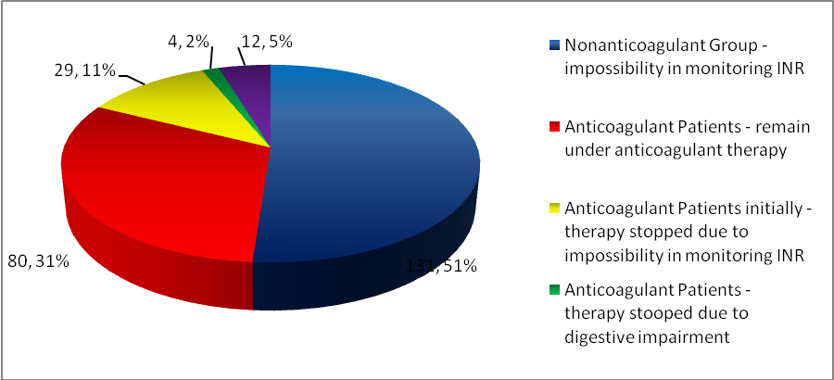
Figure 1. Anticoagulant status

Further on, we wanted to see how many patients were under an oral anticoagulation correct therapy at admission, with an INR in the therapeutic values. So, we observed that only 28.4 % had an INR value of 2-3. A percent of 44.8 % were underdosed, with an INR under 2, while 26.7 % were overdosed, with an INR over 3 (Figure 2).

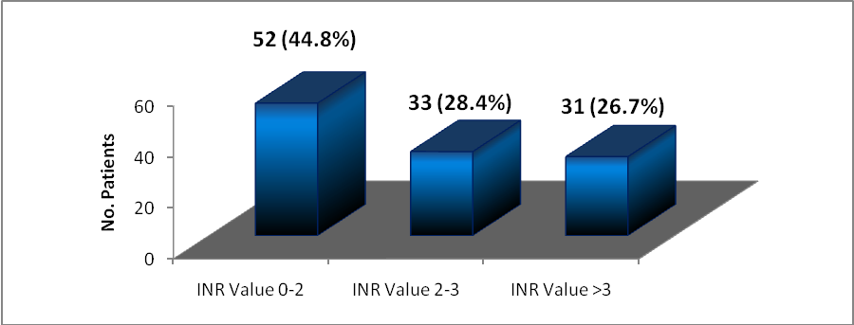
Figure 2. The appreciation of oral anticoagulation therapy by INR values at admission

Taking into fact that the new ESC guide regarding the management of atrial fibrillation, introduces age over 75 years as an indication for anticoagulation per se, we appreciated qualitatively the anticoagulation’s efficiency in different age segments (Figure 3).

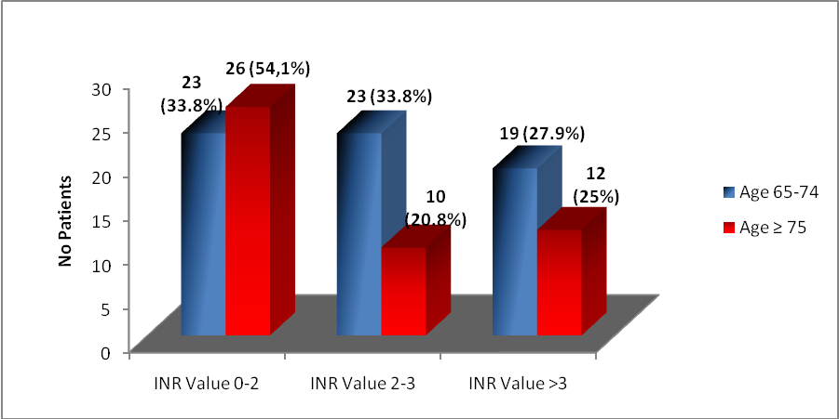
Figure3. The appreciation of oral anticoagulation therapy in age segments

What is striking is that in over 75 years age segment, more than half (54.1%) were under the therapeutic range regarding their anticoagulation status.
Reporting the INR value to sex, we observed that women were more frequently overdosed (22 out 06 60 with INR >3) than man (9 out of 53 with INR >3, P= 0.031)(Figure 4).

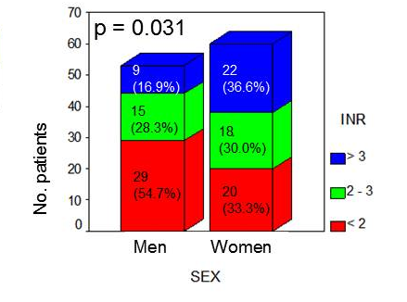
Figure 4. Distribution of the INR value by sex

Reporting the risk of stroke score (CHA2DS2VASc) to sex, we observed that the highest share was found in the middle CHA2DS2VASc scores (4–5), which were equals both in men and women, while CHA2DS2VASc scores between 1–3 were majority in men and CHA2DS2VASc between 6–8 were majority in women. The CHA2DS2VASc medium score in women was 5.1 in comparison with a value of 3.8 in men (Figure 5).
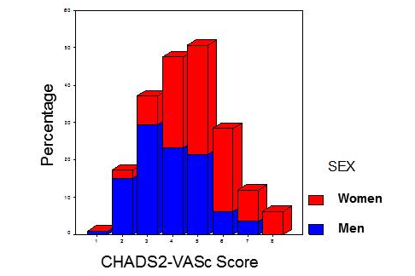
Figure 5. Distribution of the stroke risk score by sex

A number of 10 patients out of 113 which were under oral anticoagulation at admission, presented themselves with exteriorized hemorrhage (epistaxis, digestive hemorrhage, hematuria). In these patients, the bleeding risk medium score was 3.8 in comparison to 2.82 in patients with no bleeding (p= 0.001) (Figure 6).

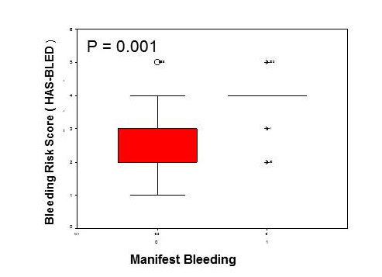
Figure 6. Relation between manifest bleeding and bleeding risk score

Unlike CHA2DS2VASc score, the bleeding risk score was equally distributed between both sexes (Figure 7).

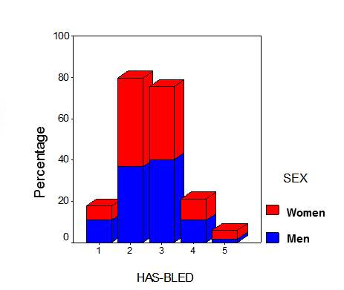
Figure 7. Distribution of the bleeding risk score by sex
The average age of women did not differ statistically from that of men: women 76.5+/-6.1 years, men 75.3 +/-5.9 years, P= 0.114 (Figure8).
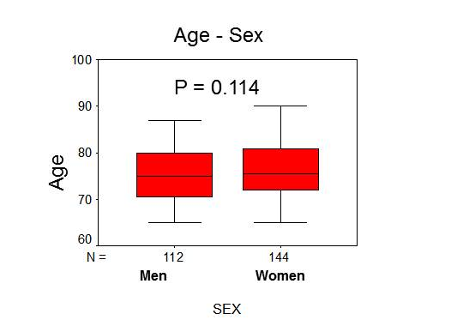
Figure 8. Average age distribution by sex

Corroborating the INR value reported to sex with CHA2DS2VASc score in relation to sex and with HAS-BLED score in relation to sex, we observed that women were more often overdosed than men and that 7 out of 10 exteriorized hemorrhages were in women.

Discussions

The main problem encountered in terms of oral anticoagulant therapy in patients with permanent atrial fibrillation is putting in balance the benefit of stroke prevention versus the bleeding risk, taking into account the fact that an elder has a higher risk for hemorrhage than a young patient. And what keeps this balance even is a properly managed oral anticoagulation therapy.
If this balance bends and patients do not receive oral anticoagulant therapy although they have indication for it, the strokes rate will increase and we put ourselves in the situation of having patients with different grades of invalidity whom requires permanent care at home as well as in hospitals. If contrary, oral anticoagulant therapy is prescribed in all patients without regard to the risk of bleeding, the mortality rate increases significantly through major bleedings.
Based on achieving a balance between the risk of stroke and the bleeding risk, an INR value between 2-3 represents the optimal range in stroke’s prevention in patients with permanent atrial fibrillation.
Controlled clinical studies show that on average patients remain at a rate of 60 – 65% in the optimal range of INR site, but many of the “real – life” studies³ suggests that this proportion would be more like 50%.
Although a new INR (1.8-2.5) target range was proposed in terms of elderly patients, it is not based on large trials.
Furthermore, cohort studies suggest a doubling of the risk of stroke in an INR value between 1.5-2, therefore⁽³⁾an INR value under 2 is not recommended.
There are a number of clinical trials in patients with atrial fibrillation comparing heart rhythm control strategy with heart rate control strategy in terms of clinical objectives⁽²⁾.
Thus AFFIRM (Atrial Fibrillation Follow-up Investigation of Rhythm Management )⁽⁴⁾study did not demonstrate any difference in mortality by all possibly cause or stroke rate between the two strategies; RACE (Rate Control versus Electrical cardio version for persistent atrial fibrillation) ⁽⁵⁾study showed no inferiority to control heart rate in comparison to rhythm control in terms of prevention cardiovascular mortality and morbidity; and AF – CHF (Atrial Fibrillation and Congestive Heart Failure)⁽⁶⁾did not observe any difference regarding cardiovascular mortality in patients with left ventricular dysfunction ( left ventricular ejection fraction ≤35%), symptoms of heart failure and a history of atrial fibrillation, in which the heart rhythm and rate were followed⁽²⁾.
One of the problems with oral anticoagulation is the interindividual and intraindividual variation in INR value.
Vitamin K antagonists, such as Warfarin, are difficult to use due to multiple interactions with other drugs and food⁽⁷⁾and because it requires careful monitoring by laboratory techniques. Thus, they are not used too often, and when they are, their discontinuation rates are high⁽²²⁻²³⁾. There are many patients who receive warfarin but do not have an adequate anticoagulation⁽¹⁷⁾. Despite the proven benefits, studies attest to its underutilization especially among elderly people who are prone to a very high risk⁽¹⁸⁻¹⁹⁾. Warfarin underutilization derives also from higher rates of hemorrhage and short-term tolerability⁽¹⁷⁾, which is making it difficult to use.
Therefore, a new effective, safe and convenient to use oral anticoagulant is needed. Dabigatran etexilat is a pro-drug, approved in stroke prevention in patients with nonvalvular atrial fibrillation in October 2010 by United States Food and Drug Administration⁽¹³⁻¹⁶⁾, but who was associated with similar rate of hemorrhage and with a higher rate of myocardial infarction compare to warfarin.
Therefore, prevention of stroke among patients with atrial fibrillation remains a challenge and a major health problem.

Conclusions

In elderly patients, in the context of morpho – functional features such as associated comorbidities, socioeconomic status, increased risk of bleeding by falling, anticoagulation therapy is more difficult to treat, to be initiated as well as driven, respectively monitored.
- In elderly patients the oral anticoagulation treatment is prescribed more carefully than in general population.
- Oral anticoagulant therapy appears not to be properly managed, about half of patients not reaching treatment targets.
- The impossibility to monitor INR values appears to be the main barrier regarding oral anticoagulant therapy in these patients.
- We can count on a bleeding risk score under 3 in order to manage safely oral anticoagulant therapy at any age.
Study limits
Being a retrospective study, patients were not followed in order to calculate the rate of cardiovascular events and to assess the effectiveness of anticoagulation.
But retain the data in the literature that the incidence of stroke in patients with atrial fibrillation is significantly reduced by oral anticoagulation, with a maximum benefit of an INR value greater than or equal⁽⁸⁾to 2.
However, we believe that this work has important practical applications, because it draws attention to the real problems that exist in the management of oral anticoagulant therapy in elderly patients and the imperative necessity of finding solutions for optimization of therapy, at least in this category of patients.

References
- Camm AJ, Kirchhof P, Lip GYH, et al. Guidelines for the management of atrial fibrillation. Eur Heart J 2010.
- Carmen Ginghina Mic tratat de cardiologie, Ed. Academiei Romane 2010
- Steven R. Kayser, Michael L. Hess, Maureen P. Flattery Consideration in drug therapy
- AFFIRM Investigators. A comparison of rate control and rhythm control in patients with atrial fibrillation. N Engl J Med 2001; 347:1825-33.
- Van Gelder IC, Hagens VE, Bosker HA, et al. A comparison of rate control and rhythm control in patients with recurrent persistent atrial fibrillation. N Engl J Med 2002; 347:1834-40.
- Roy D, Talajic M, Nattel S, et al. Rhythm control versus rate control for atrial fibrillation and heart failure. N Engl J Med 2008; 358:2667-2677.
- Gherasim L., E. Apetrei Actualitati in cardiologie - Probleme actuale in tratamentul fibrilatiei atriale.Ed. Medicala Amaltea 1998.
- Elaine M. Hylek, M.D., M.P.H et al, .Effect of Intensity of Oral Anticoagulation on Stroke Severity and Mortality in Atrial Fibrillation N Engl J Med 2003; 349:1019-1026
- Miyasaka Y, Barnes ME, Gersh BJ, Cha SS, Bailey KR, Abhayaratna WP, Seward JB, Tsang TS. Secular trends in incidence of atrial fibrillation in Olmsted County, Minnesota, 1980 to 2000, and implications on the projections for future prevalence. Circulation 2006;114:119–125.
- Naccarelli GV, Varker H, Lin J, Schulman KL. Increasing prevalence of atrial fibrillation and flutter in the United States. Am J Cardiol 2009;104:1534–1539
- Lip GY, Frison L, Halperin J, Lane D. Identifying patients at risk of stroke despite anticoagulation. Stroke 2010.
- Pisters R, Lane DA, Nieuwlaat R, de Vos CB, Crijns HJ, Lip GY. A novel user friendly score (HAS BLED) to assess one-year risk of major bleeding in atrial fibrillation patients: The Euro Heart Survey. Chest 2010;
- Turpie AG (January 2008). "New oral anticoagulants in atrial fibrillation". Eur Heart J29 (2): 155–65. doi:10.1093/eurheartj/ehm575. PMID 18096568.
- Connolly S, Ezekowitz MD, Yusuf S, et al. (2009). "Dabigatran versus warfarin in patients with atrial fibrillation". N Engl J Med 361 (12): 1139–51. doi:10.1056/NEJMoa0905561. PMID 19717844.
- Boehringer wins first US OK in blood-thinner race". Reuters (Reuters). 2010-10-19. http://www.reuters.com/article/idUSN1916563620101019. Retrieved 2010-10-20.
- FDA approves Pradaxa to prevent stroke in people with atrial fibrillation". Food and Drug Administration 2010.
- Elaine M. Hylek, Carmella Evans-Molina, Carol Shea, Lori E. Henault and Susan Regan Major Hemorrhage and Tolerability of Warfarin in the First Year of Therapy Among Elderly Patients With Atrial Fibrillation Circulation 2007;115;2689-2696; originally published online May 21, 2007; DOI: 10.1161/CIRCULATIONAHA.106.653048
- Bungard TJ, Ghali WA, Teo KK, McAlister FA, Tsuyuki RT. Why do patients with atrial fibrillation not receive warfarin? Arch Intern Med. 2000;160:41– 46.
- Gage BF, Boechler M, Doggette AL, Fortune G, Flaker GC, Rich MW, Radford MJ. Adverse outcomes and predictors of underuse of antithrombotic therapy in Medicare beneficiaries with chronic atrial fibrillation. Stroke. 2000;31:822– 827.
- Birman-Deych E, Radford MJ, NilasenaDS, Gage BF. Use and effectiveness of warfarin in Medicare beneficiaries with atrial fibrillation. Stroke 2006;37:1070-4.
- Hylek EM, Evans-Molina C, Shea C, Henault LE, Regan S. Major hemorrhage and tolerability of warfarin in the first year of therapy among elderly patients with atrial fibrillation. Circulation 2007;115: 2689-96

