PARTICULAR ETIOLOGY OF SEVERE HEART FAILURE

Mihaela Nistor¹, Anca Mihăilescu², Adriana Gurghean², Doru Grig Orleschi³, Minerva Muraru⁴, Ion Bruckner⁴
¹Medic rezident endocrinologie
²Medic primar medicină internă, Spitalul Clinic Colțea
³Medic rezident neurologie
⁴Prof. dr. medic primar medicină internă, Spitalul Clinic Colțea
ella_korn@yahoo.com.au

Abstract
Cardiac amyloidosis is a progressive form of infiltrative cardiomyopathy that is associated with a reserved prognosis. Patients diagnosed with the primary AL form of the disease invariably display cardiac localization with clinical manifestations of varying amplitude. As part of cardiac amyloidosis, four cardiovascular syndromes may be described: restrictive cardiomyopathy, orthostatic hypotension, bundle blocks and systolic heart failure. We submit a case of primary light-chain amyloidosis presenting, when diagnosed, heart failure with severe depression of systolic function. In context, the patient evolved poorly in spite of chemotherapy which is normally associated with an increase in life expectancy.
Keywords: cardiac amyloidosis, light-chain amyloidosis, heart failure, chemotherapy.

Rezumat

Amiloidoza cardiacă este o formă progresivă de cardiomiopatie infiltrativă care se asociază cu un prognostic rezervat. Pacienții diagnosticați cu forma cu lanțuri ușoare primară a bolii prezintă invariabil afectare cardiacă, cu manifestări clinice de amplitudine diferită. Ca parte a amiloidozei cardiace, pot fi descrise patru sindroame cardiovasculare: cardiomiopatia restrictivă, hipotensiunea ortostatică, blocurilele cardiace, insuficiența cardiacă sistolică. Prezentăm un caz de amiloidoză cu lanțuri ușoare primară care prezenta, în momentul diagnosticului, insuficiență cardiacă cu afectare severă a funcției sistolice. În context, pacientul a înregistrat o evoluție proastă, în ciuda chimioterapiei care este de obicei, asociată cu creșterea speranței de viață.

Cuvinte cheie: amiloidoza cardiacă, amiloidoză cu lanțuri ușoare, insuficiență cardiacă, chimioterapie.

CASE PRESENTATION
A 55 year old man, presented with asthenia and fatigue , dyspnea on exertion, mild edema in the lower extremities, and excessive sweating. The symptoms are chronic in nature, progressing slowly over several years. He had been diagnosed several years ago with severe systolic heart failure.
The medical history included hypertension (TAS max = 220 mmHg, an isolated determination; the average value between 100 and 120 mm Hg, under medication), vitiligo and hypercholesterolemia, all diagnosed simultaneously ten years ago. His medical treatment included a dihydropyridinic calcium channel blocker, statin, and antiplatelet drugs. The patient did not work in a toxic environment, quit smoking at age 50, after smoking 10 packs-year, rarely drank alcohol and denies illicit drug use; The family history includes stroke (father).
On physical examination the patient was in distress, body temperature was 36,7 ºC, blood pressure 100/70 mmHg, the pulse 90 beats per minute, the respiratory rate 16 breaths per minute and oxygen saturation 95% while he was breathing ambient air; the skin showed vitiligo, mild symmetric leg edema; the thorax exhibited dorsal kyphosis, symmetric crepitations on auscultation of the inferior portion with the lungs otherwise clear. Evaluation of the anterior thorax shows an enlarged precordium and the apex beat in the 6th intercostal space on the mid clavicular line. Auscultation reveals a normal rhythm with a pansystolic murmur II/VI at the apex without irraditation, and protodiastolic gallop. The abdomen moved with breathing and showed no signs of peritoneal irritation; an enlarged liver extended 3 cm below the costal margin, with stasis issue. Clinical, radiological and biological of heart failure, without other cardiac pathology ,outside pressure values ​​unsupported (without clinical manifestations of ischemic heart disease, significant valvular heart disease,) have suggested a less common etiology of heart failure.
For confirmation and establishing etiology, we ran a series of investigations. The NT-proBNP level spiked well above normal (12100pg/mL) suggests the above mentioned diagnosis. No other biologic anomalies were detected at this time. Chest X-rays show cardiomegaly, proeminent upper lobe veins and diffuse interstitial shadowing. ECG reveals sinus rhythm with bifascicular block (first degree atrioventricular block and left anterior hemiblock) with a Q wave in DII, DIII, aVF and V1-V4, suggesting an old myocardial infarction.
(Figure 1).Echocardiography identified severe concentric ventricular hypertrophy (interventricular septum = 23 mm, posterior wall = 18 mm), hypertrophy of the right ventricular’s free wall (10mm), bi-atrial enlargement (left atrium = 48mm, right atrium = 47mm), severe systolo-diastolic dysfunction (pseudo normal aspect) with an estimative ejection fraction of the left ventricle of 30% and E/A = 1,8. There was also mild aortic and tricuspid regurgitation, eccentric mitral insufficiency and mild pericardial effusion coupled with ventricular wall thickening, sparkling and granular texture. (Figure 2). Clinical and echocardiographic data strongly suggest an infiltrative cardiomyopathy. Given the absence of uncontrolled arterial hypertension or aortic valve stenosis, the left ventricle abnormalities seem to be the result of something other than compensatory hypertrophy, more so when the right ventricle is similarly affected (RV external wall = 10mm). Restrictive cardiomyopathy seems the likely cause, with amyloidosis its most frequently observed etiology. Amongst others, hypereosinophilic endomiocardial disease had been excluded by a normal eosinophilic cell count (Eo = 0,9%, or 100/μL) and hemochromatosis requires high values of blood iron (whereas the patient had 62 μg/dL).
Thus, a subcutaneous fat biopsy was requested, which identified amyloid deposition (positive staining with Congo red). Once the diagnosis had been established, the next step was identifying the exact subtype in order to properly treat the patient. AA type secondary amyloidosis seems unlikely in this patient, since there is no personal history of chronic inflammatory disease that would induce such alterations and cardiac tropism is extremely rare for this subtype. When the heart is involved, the differential diagnosis is essentially restricted to transthyretin associated amyloidosis (senile or familial form) or AL amyloidosis. The patient's age and the absence of family history excludes the senile form . Knowing the correlation between primary (AL) amyloidosis and clonal plama cell dyscrasia (multiple myeloma, Waldenstrom's macroglobulinemia, non-Hodgkin's lymphoma) we recommended electrophoresis and immune-electrophoresis of serum proteins. No monoclonal peaks were recorded but this is not an exclusion criterion for the AL form. The final diagnosis was set upon the discovery of high level serum lambda light-chain with a very low kappa/lambda ratio in the absence of renal failure. Therefore, we are confronted with a case of primary AL amyloidosis bearing heavily upon the myocardium.
The patient made monthly follow-up visits for a year, during which he was submitted to 7 chemotherapy pulses and specific treatment for heart failure with no significant improvement (end NT-proBNP = 19000pg/mL, which is an indicator of poor prognosis); moreover , the range of the cardiac involvement is broadened by conduction system disease and paroxysmal arrhythmias (atrial fibrillation, and ventricular tachycardia). In time, other signs and symptoms specific to amyloidosis become manifest: amyloidotic polyneuropathy with its sensitive (symmetric pain and paresthesiae in the upper extremities) and autonomic (excessive sweating, diarrhea, orthostatic hypotension) components. Also, hepatomegaly, as a consequence of heart failure or amyloid deposits, is seen. Purpuric elements become apparent in the lower extremities and subclinical hypothyroidism (due to amyloid deposits or antiarrhythmic drugs) is revealed by ancillary testing.
A year after the first admittion the patient is admitted for decompensation of chronic heart failure (rest dyspnea, orthopnea and extensive edema) caused by an acute lower respiratory tract illness associated with fever 38ºC, cough and purulent sputum. Furthermore, clinical examination and ancillary testing reveal high quantity right-side pleural effusion with mass effect upon the heart and mediastinum, disproportionate to the severity of the heart failure . (Figure 3). The pleural effusion is characterized as transudate but with cellular elements. Thoracentesis coupled with intravenous loop diuretics alleviate some of the symptoms but do not achieve full recovery.
Intractable pleural effusion contributes to a negative prognosis giving the patient a life expectancy of 1.5 months. Our patient deceased two months later, at his house. This is the reason why we do not have an anatomopathological results

DISCUSSION
Amyloidosis encompasses a wide range of disease characterized by extracellular insoluble protein fibril deposits with a tendency to aggregate in various organs affecting their function.
Presently, there are 21 different proteins capable of generating amyloid fibrils. The most common of these are AL amyloid and transthyretin associated amyloid, although rarer forms such as secondary (AA) amyloid, β2 microglobulin, Aβ protein, and apolipoprotein I and II do exist. Each has its own organ tropism: β2 microglobulin in the joints, AA fibrinogen - the kidney, transthyretin in peripheral nerves, and light chains virtually everywhere. One in four patients is admitted for single organ involvement, a base element for prognosis.
The case presented is illustrative for primary amyloidosis having as first presentation cardiac signs and then systemic manifestations. The patient died with septic complications. The particularity of our case is the preservation of renal function during the whole evolution. Cardiac manifestations included all clinical syndromes described in amyloidosis (heart failure, orthostatic hypotension, rrhythm and conduction abnormalities). Survival from diagnosis (in late stage disease) was greater than expected (one year and two months), our patient having multiple negative predictors (severe cardiac involvement with very high levels of NT-proBNP, systemic disease and altered Karnofski index).

Bibliography
1.” Amyloidosis, Immunoglobulin-Related”, Slavomir Urbancek, MD, PhD, Department of Dematology, FD Roosevelt Hospital, Slovakia, june 2008
2.”A heavy heart” , Amy Leigh Miller MD, PhD, Rodney H. Falk MD, Bruce D. Levy MD, Joseph Loscalzo MD, PhD; N Engl J Med october 2010
3.”Light-Chain Deposition Disease”, Yasodah Jayamohan MD, Transfusion Medicine Fellow, Hoxworth Blood Center, University of Cincinnati Medical Center
4.”Molecular Maechanisms of Amyloidosis”, Giampaolo Merlini MD, Vittorio Bellotti MD, PhD; N Engl J Med august 2003
5.”Pleural amyloidosis attesting to generalised amyloidosis”, Aichaouia C, Ben Meftah MR, M'hamdi S, Laabidi J, Moatamri Z, Haddaoui A, Khadhraoui M, Cheikh R ; Rev Pneumol Clin. June 2010
6.”Principles of Internal Medicine”, Harrison, 17th Edition
7”Successful management of refractory pleural effusion due to systemic immunoglobluin light chain amyloidosis by vinvristine, adriamycin and dexamethasone chemotherapy”, Araoka T, Takeoka H, Nishioka K, Ikeda M, Kondo M, Hoshina A, Kishi S, Araki M, Mimura R, Murakami T, Mima A, Nagai K, Abe H, Doi T
8.”Cecil Textbook of Medicine”, Bennett and Plum, 20th Edition
9.”Treatment of diuretic refractory pleural effusions with bevacizumab in four patients with primary systemic amyloidosis”, Robert J Hoyer, Nelson Leung, Thomas E. Witzig, Martha Q Lacy; American Journal of Hematology, february 2007
10. “Braunwald's Heart Disease, a textbook of cardiovascular medicine”, Libby, Bonow, Mann, Zipes.
11.. Morie A. Gertz I don't know how to treat amyloidosis.Blood2010 116: 507-508

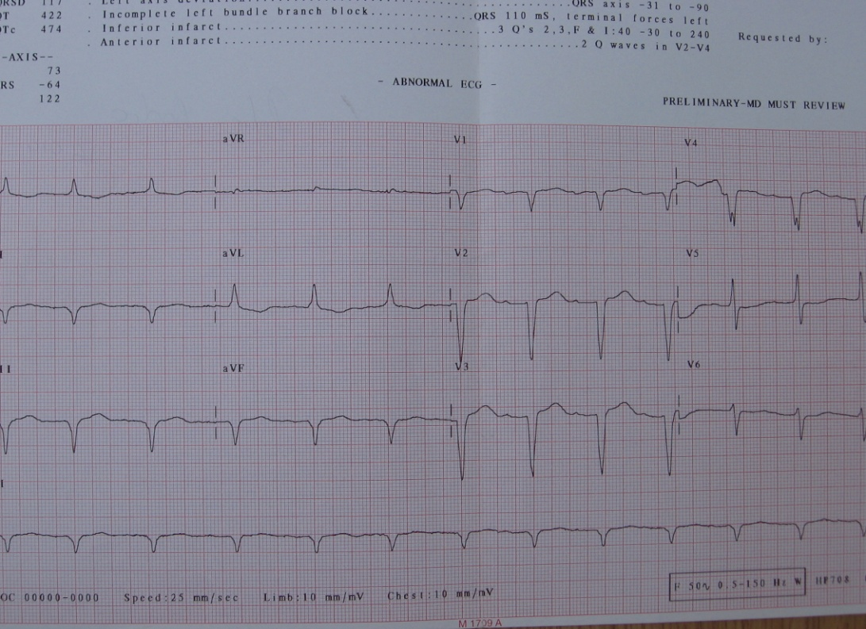
Figura 1.

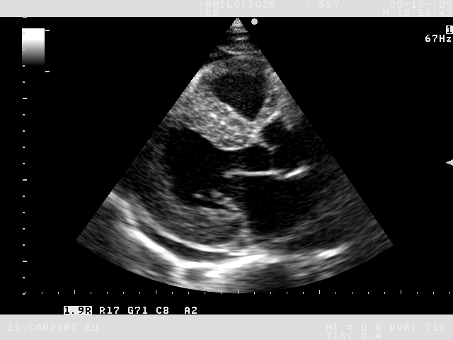
Figura 2

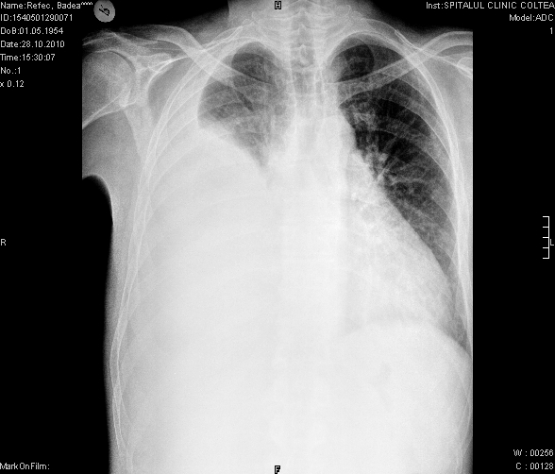
Figura 3

