HEPATITIS C VIRUS INFECTION IN PATIENTS OF THE UNIVERSITY EMERGENCY HOSPITAL BUCHAREST HEMODIALYSIS CENTER BETWEEN 2005- 2010

D. Olteanu¹, A.C. Diaconescu¹, S. Scărlătescu, MD²
¹I Clinic of Internal Medicine and Nephrology SUUB
²Charleston Area Medical Center WV, USA
aldiaconescu@gmail.com

Rezumat
Infecţia cu virus hepatitic C are o prevalenţă crescută în rândul hemodializaţilor, mereu mai mare decât în populaţia generală care este la rândul ei mult variabilă în funcție de regiune. În unele ţări, cum este şi cazul României, atât prevalenţa cât şi incidenţa rămân foarte crescute, indicând calea majoră de transmitere ca fiind cea nosocomială, probabil din cauza resurselor limitate pentru o populaţie dializată în creştere rapidă. În ceea ce priveşte datele capitalei, în afara celor de la centrul cel mai vechi de dializă, restul erau cvasi-inexistente iar cele ale SUUB nu păreau deloc sumbre.
Infecţia apare, ca şi în populaţia generală la vârste tinere, importante socio-economic. Probabil că aderenţa strictă la precauţiunile universale este suficientă în centrele de hemodializă cu prevalenţă joasă. Sugerăm necesitatea unor programe de vaccinare anti-HBV adresate specific pacienţilor dializaţi.
Cuvinte cheie: hepatită C, hemodializă, prevalenţă, izolare.

Abstract
Hepatitis C-virus infection has a higher prevalence among hemodialysis patients, always higher than in the general population which also varies by region.
In some countries, as is the case in Romania both prevalence and incidence remain very high, indicating that the major route of transmission is the nosocomial one, most likely due to limited resources in a rapidly growing dialysis population
HD data from SUUB do not look ominous but, except for the oldest HD center, the data from other Bucharest units are almost non existent.
As in the general population, infection occurs in hemodialysis patients at a young age, with the most significant socio-economic impact.
Strict adherence to universal precautions is most likely an effective and sufficient strategy in low-prevalence hemodialysis centers.
We suggest the need for anti-HBV vaccination programs specific to the dialysis patients.
Keywords: hepatitis C, hemodialysis, prevalence, isolation.

Introduction

Hepatitis C virus (HCV) infection has a high prevalence among hemodialysis (HD) patients worldwide⁽⁾. But the prevalence of infection varies greatly by country (between 1.9 and 84.6% in recent reports⁽⁾ and even within individual countries⁽⁾. High seroprevalence areas (> 40%) of HCV infection were noted in Brazil, Peru, former Bosnia-Herzegovina, Senegal, Syria, Tunisia, Pakistan, Saudi Arabia, Iran and Moldova (the geographical region of Romania). In Europe the prevalence of HCV infection among hemodialysis patients is always higher than in the general population but varying by region with a lower prevalence in northern countries ( England 2%, Sweden 8.8% ) and higher in the south (Spain 25% Italy 27%, Turkey 30%)⁽,⁾.
In Moldova (Covic et al⁽⁾., 1999), one of the three historical regions of Romania, HCV infection was found in 75% of hemodialysis patients, hepatitis B virus (HBV) infection in 17%, and coinfection B + C in 10%. Anti-HCV antibodies were found positive in 47% patients at the time of the entry in hemodialysis, before starting. The above article refers to an incidence of 80.6%⁽⁾ in dialysis center of Carol Davila Hospital Bucharest, an appaling prevalence, of great concern, but these data are not recent. In the capital the other data were almost non-existent, other than those from the oldest dialysis center, but those of SUUB not seems to be as concerning as those stated above.

Material and methods

The Haemodialysis Centre of Emergency University Hospital Bucharest operated in 4 dayshifts between 2005-2009 , Monday-Wednesday-Friday (MWF) and Tuesday-Thursday-Saturday (TTS) and in 2 dayshifts in 2010. Dialysis is performed using Fresenius 4008 B, 4008 S and 4008 H monitors. The acid concentrate used is AF12 Fresenius and bicarbonate BI 84 Fresenius.
HCV positive patients have dedicated machines . There are no separate "yellow rooms”, but the monitors are relatively isolated permitting separate access similar to those for hepatitis B patients.
Heparin Sodium was most commonly used, but in some cases we used fractionated heparins (nadroparine / fraxiparine, dalteparin / , enoxaparin / clexane and tinzaparine / innohep). Heparin Sodium is packaged in multidose vials and disposable syringes are filled upon unsealing then the vials are discarded. The same goes for tinzaparine. Other fractionated heparin were dispensed in prefilled syringes.
The Erythropoietin used was the original beta, NeoRecormon.
No staff member is infected with HCV. In one case prophylaxis with pegylated interferon was administered after contact with the blood from a patient with significant viremia. Most staff members are vaccinated against HBV but neutralizing antibody titers are not routinely measured.
The center employs a full time psychologist.
The center serves an area that inludes Bucharest, Ilfov, and adjacent counties (GR, IL, DB, TR etc.). There were also transiting patients from AG, BV, CT, DB, GR, MH, OT, PH, etc. At the beginning of the study diabetic patients were directed to the IDNBM Paulescu center but this policy was quickly abandoned.
Testing patients for the presence of HCV antibodies was performed at entry in hemodialysis and subsequently twice a year. Initially MonoLisa third generation (BioRad Laboratories) tests were used, and currently the chemiluminescence technique (Architect and 1000 analyzer and Abbott reagents).
41 anti-HCV positive patients were identified during 2005-2010.
The individual cases( some patients have more than one entry/medical record number) were distributed as follows: 137 (2005) + (160-106) (2006) + (202-110) (2007) + (210-113) (2008) + (222-105) (2009) + (186 - 39) (2010) = 644 out of 1304 on dialysis inclusion (see table 1).
The difference is explained by patients' readmission at SUUB for other pathologies (in transit), several times. For example: a patient with multiple myeloma that received chemotherapy regimens in Hematology Clinic SUUB was reincluded 8 times in 2010.
Of these 644 individual cases, consistent data are available for 488 .
We used Microsoft Excel (MS Office XP) for databases and graph making and Epi Info ™ Version 3.5.1 for statistical analysis (freeware CDC website: http://wwwn.cdc.gov/epiinfo/). We used Bartlett's chi square to determine an appropriate method of testing and then the ANOVA test for homogeneous populations or Kruskal-Wallis H (equivalent of Chi-square) for the inhomogeneous ones.

Results

Synopsis of patients treated in the SUUB center in 2005-2010 is given below:

Table 1. HD patients treated during 2005-2010 in SUUB
 | january | in | total | uniques | transit | december | ARF* | ARF % | deaths | deaths %
2005 | 94 | 61 | 155 | 137 | 16 | 106 | 9 | 6.57% | 24 | 17.52%
2006 | 106 | 79 | 185 | 160 | 32 | 110 | 19 | 11.88% | 24 | 15.00%
2007 | 110 | 98 | 208 | 202 | 19 | 113 | 25 | 12.38% | 51 | 25.25%
2008 | 113 | 110 | 223 | 210 | 49 | 105 | 21 | 10.00% | 48 | 22.86%
2009 | 105 | 169 | 274 | 222 | 145 | 39 | 35 | 15.77% | 55 | 24.77%
Oct-10 | 39 | 220 | 259 | 186 | 183 | 33 | 0 | 0.00% | 43 | 23.12%
 |  | 737 | 1304 | 644 | 444 |  | 109 |  | 245

*ARF- acute renal failure

Between January 2010 and 31 October 2010, (due to a drastic reduction in the number of dialysis patients by transferring 81 of them to a private center in December 2009) there were 220 new hemodialysis patients enrolled at the center. In 2010 the dialysing of ARF cases (except for acute exacerbation of CKD requiring dialysis) was stopped due to a change of legal rules. In contrast, during the same year, despite reducing by half the number of shifts and of established patients to below 40%, the total number of dialysis patients did not diminish. This was a consequence of a dramatic increase in the number of patients in transit through our center-figure 1:

Figure 1. Annual hemodialysis patients that are transiting SUUB center
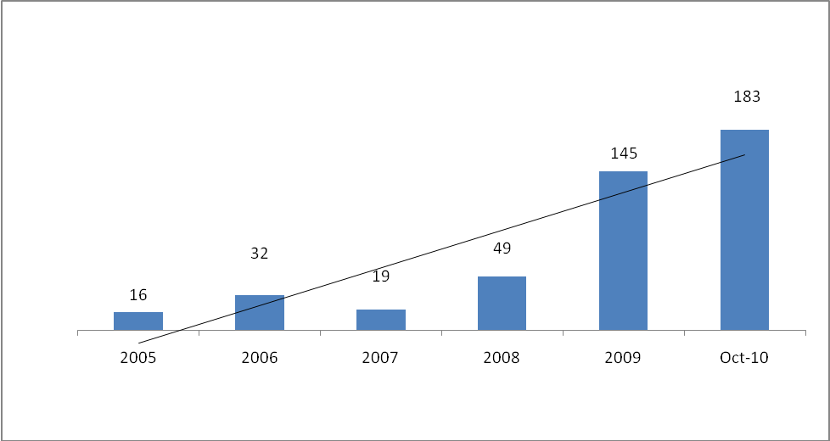

and thus an increase in patient ratio (in transit) / (resident) from less than 1 (16/110 = 0.15 in 2005) to reverse ratio, higher than 1 (183/39 = 4.69), ie a 32 fold increase.
The age range at entry was 17.62 to 87.35 years with mean age of 60.57 ± 15.42 years .
The age group distribution was - Table 2, Figure 2.

Table 2 Figure 2
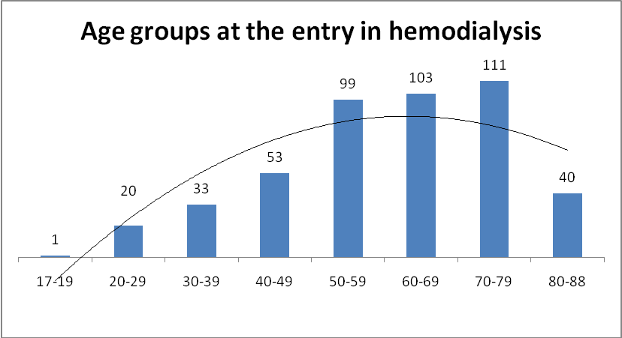
17-19 | 1 | 0.20%
20-29 | 20 | 4.10%
30-39 | 33 | 6.76%
40-49 | 53 | 10.86%
50-59 | 99 | 20.29%
60-69 | 103 | 21.11%
70-79 | 111 | 22.75%
80-88 | 40 | 8.20%
no ID | 28 | 5.74%
Total | 488 | 100%

This follows an assimilable Gaussian distribution. The advanced age of our dialysis population is also obvious.
The overall calculated duration of dialysis was 1.53 years average, but with a large standard deviation of 2.59 years and a maximum of 17.77 years - calculated by the difference between the date of exit from dialysis and the date of entry for patients no longer active , and the difference between the date of October 31, 2010 (end of study) and the entry date for those who are still in dialysis - table3.

Table 3. Mean dialysis years in the SUUB center
No longer active max 17,77 mean 1,07 (sd 2,40) (min 0,00)
Active max 12,46 mean 4,7 (sd 3,66) (min 0,21)

We found a great predominance (310/488 = 63.52%) of pensioners: according Romanian legislation the diagnosis of end-stage renal disease in dialysis is a qualifier for long term disability (grade I severe disability) and attendant care services.
Only 4% preferred to continue working (with reduced working hours). They were fit in the dialysis schedule after their working hours.
Those unemployed, 3%, also promptly received disability benefits after starting dialysis.
Bucharest provided the largest number of patients (about 290,) followed by Ilfov, Giurgiu and Argeş counties( double digits) and the rest in single digits for a total of 25 counties- Figure 3.

Figure 3. Home counties of hemodialysis patients

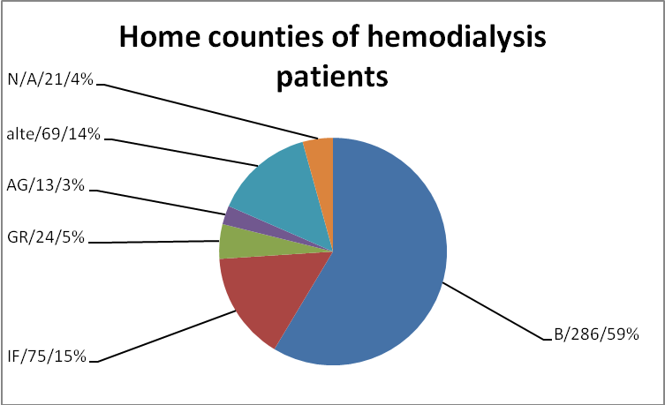

Ethnicity also varied: mostly Romanian (about 3 / 4) followed by Roma (about 1 / 5) but also a few transiting Hungarians, two Greek and one Italian, Turkish, Persian, Hebrew, Polish and Tagalog.
The main causes for renal failure were chronic glomerulonephritis and essential hypertension. The (relatively) low percentage of diabetes is explained by the previous policy , now abandoned, of diverting this category to IDNBM Paulescu.
28% were non-hypertensive while out of 72% HTN, 56% (more than half) had secondary HTN.
This ratio secondary/essential hypertension of 3.43 indicates the high probability that the diagnosed. hypertension is secondary.
Central venous catheter use is overwhelmingly prevalent: 91%, indicating the initiation of chronic HD on an emergency basis, and not just need for temporary access due to graft issues/malfunction – figure 4.
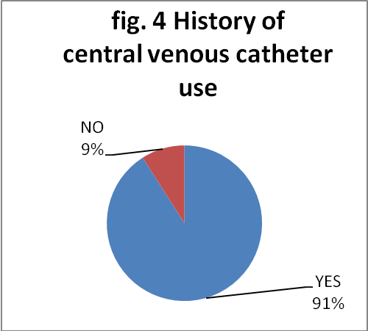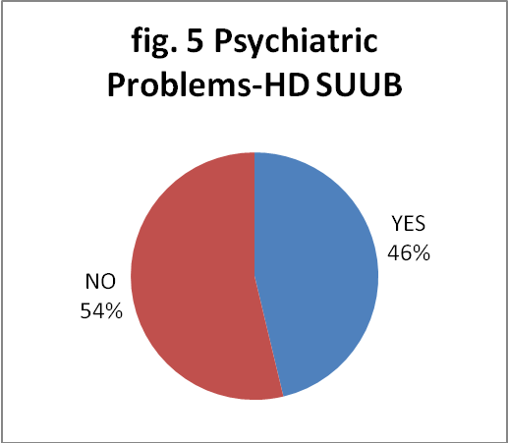

The presence of comorbid psychiatric illnesses is significant at 54% including depression, dementia (usually vascular or mixed), various personality disorders (including antisocial, border-line and paranoid), substance abuse, etc - (but data are available for only 43.85% of patients) – figure 5. 28% of patients admitted to using alcohol.
The patients were discharged mainly by transfer to a different center (nearly half, 47%), followed by death (28%) and loss of records (17%, which includes the patients who expired at home or in different SUUB clinics, not Nephrology or ICU, and discharged from other departments).
There were only five renal transplants (RT, 1.02%) and four transfers to peritoneal dialysis (PD, 0.82%) during that period - figure 6.

Figure 6. The discharge modality
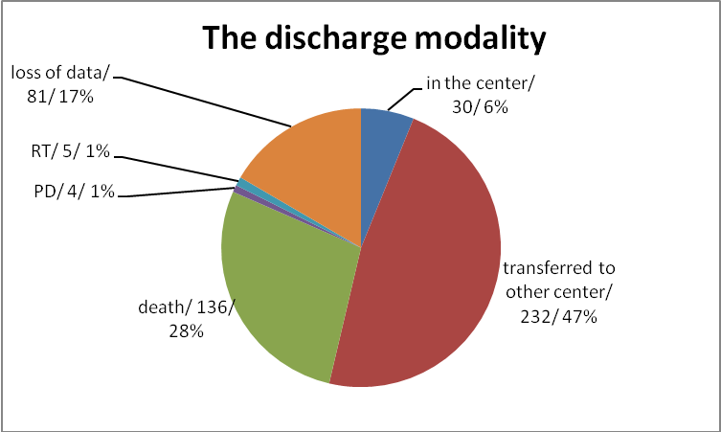
The number of transiting hemodialysis patients through SUUB center was significant: about one third (ie 32%).
HCV infection in HD SUUB. Comparative data vs total
Evolution of HCV infection at SUUB during the survey period - Table 4.

Table 4. Absolute number of HCV infected patients vs total

 | january | in | out | balance | total HCV+ | total HD
2005 | 8 | 3 | 0 | 3 | 11 | 137
2006 | 1 | 1 | 1 | 0 | 11 | 160
2007 | 4 | 4 | 1 | 3 | 14 | 202
2008 | 4 | 4 | 3 | 1 | 15 | 210
2009 | 11 | 11 | 18 | -7 | 8 | 222
Oct-10 | 10 | 10 | 15 | -5 | 3 | 186
A large increase in the absolute number of new cases of HCV infection was noted starting in 2009 (but all of them were new start HD HCV-positive patients, not seroconversions from previously seronegative patients) - figure 7.

Figure 7. Incidence of HCV in HD-SUUB, 2005-2010
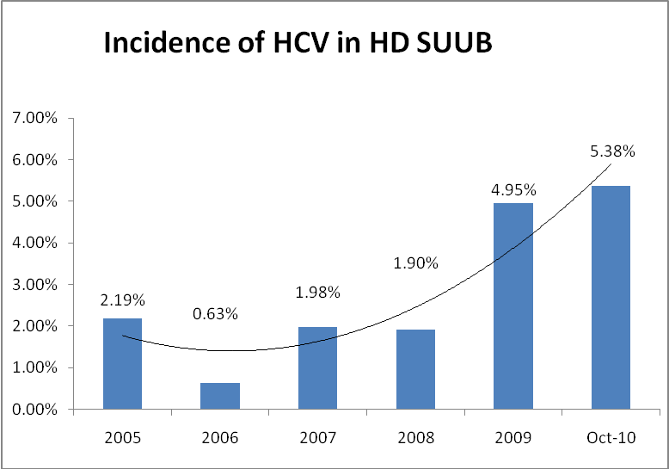

However during 2009, the total number of HCV positive hemodialysis patients decreased (in absolute value, calculated as the arithmetic sum between those present at the beginning of the year plus new entrants minus the discharges during the same year).
The explanation lies in the fact that although there has been a growing number of new cases, there were more exits from the center (deaths, transfers to different center, peritoneal dialysis, transplant or any loss of records) so the prevalence decreased.
HCV-infected versus noninfected data -Table 5.

Table 5. HCV infected vs non-infected
 | HCV- | HCV+ | p
Age at entry in HD(yrs) | 61,58±14,98 | 50,24±16,18 | 0,0000 ANOVA
Actual Age (yrs) | 60,53±13,66 | 53,48±16,96 | 0,0119 ANOVA
Years of HD-disc. pts. | 0,92±2 | 2,77±4,7 | 0,0022 Kruskal-Wallis
Years of HD -current pts | 3,06±3,3 | 5,14±4,76 | Ns
Sex M/F % | 55,9/44,1 | 58,5/41,5 | Ns
Pensioner/other % | 90,2/9,8 | 89,7/10,3 | Ns
County B/IF/other % | 62,5/15,3/22,2 | 46,3/24,4/29,3 | Ns
Urban/rural % | 70,7/29,3 | 53,7/46,3 | 0,02 Fisher exact; 0,01 mid P exact
Ethnic(romanian/oth) % | 82,3/17,7 | 70,7/29,3 | 0,07 Fisher exact; 0,05 mid P exact
Day (MWF/TTS)% | 81,8/81,7 | 18,2/18,3 | Ns
Shift (1/2/3&4)% | 28,9/44,4/26,7 | 29,3/51,2/19,5 | Ns
HT (non/E/S) % | 30,3/13,3/56,4 | 19,5/29,3/51,2 | 0,03Chi P
Anemia (Y/N) % | 85,3/14,7 | 94,7/5,3 | 0,09 Fisher exact; 0,05 mid P exact
Hb at HD initiation | 8,83±1,54 | 8,88±1,85 | Ns
EPO | 4196,08±3041,5 | 4636,36±3314,91 | Ns
Transfusions (Y/N)% | 47,2/52,8 | 72,2/27,8 | 0,0057 Fisher exact; 0,0037 mid P exct
Nr of transfusions | 1,42±1,94 | 1,81±1,96 | Ns
Weight (kg) | 69,97±11,54 | 65,36±12,75 | 0,026 ANOVA
Height (m) | 1,69±0,07 | 1,66±0,1 | Ns
BMI (kg/m²) | 24,37±3,73 | 23,75±3,77 | Ns
Surgery (Y/N)% | 48/52 | 63,6/36,4 | 0,08 Fisher exact; 0,05 Mid P exact
Hepatic Citolysis (Y/N)% | 25,4/74,6 | 67,6/32,4 | 0,000003 Fisher x 0,000001 Mid P x
Centr ven catheter/graft % | 14/86 | 10.3/89.7 | Ns
CVC history (Y/N) % | 91/9 | 91,2/8,8 | Ns
Psychiatric dis (Y/N) % | 55,3/44,7 | 45,7/54,3 | Ns
Alcohol cons (Y/N)% | 29,6/70,4 | 20,7/79,3 | Ns
Still in RRT (Y/N)% | 55,6/44,4 | 75/25 | 0,01 Fisher exact; 0,008 Mid P exact
Transit (Y/N) % | 31,8/68,2 | 34,1/65,9 | Ns
HBV(Y/N) % | 1,3/98,7 | 4,9/95,1 | Ns

RRT= renal replacement therapy

Discussion

We found that younger age is risk factor for HCV infection (both current age and the age at HD start). We also found a longer duration of dialysis for infected than uninfected (for the patients discharged/lost for follow up).
While we and some authors⁽⁾ found the younger age to be a risk factor, other authors found older age to be a risk factor⁽,⁾.
Regarding the duration of dialysis, however, our data are consistent with most authors⁽,,,,,,⁾.
Various authors found a correlation between diabetes and HCV infection⁽,⁾. We did not find any correlation probably because of the previous policy of diverting such cases to IDNBM Paulescu. A 2010 study (unpublished data) that included SUUB and three private centers found diabetes significantly more than hypertensive nephrosclerosis (Chi-square p = 0.0072) as the etiology of renal failure in infected patients.
We found the presence of anemia in uninfected rather than infected patients but with limited statistical significance. Also we have not found significant differences in hemoglobin levels between infected and uninfected at the time of HD initiation.
The impact of HCV infection on anemia in hemodialysis patients appears to be a positive one – according to Sahin et al⁽⁾ , due to a decreased need for erythropoietin (EPO) and iron. Recently (Khurana A et al⁽⁾, 2008) argues that for a small number of HCV + hemodialysis patients, there is minimal or no need for EPO. We did not find any statistically significant data on EPO doses.
A positive history of transfusion was significantly different, more frequent in infected. Older studies found blood transfusions (especially before the 90’s) as risk factor⁽,,,⁾. Recent studies, however, did not find transfusions as an independent risk factor in the spread of HCV among dialysis patients⁽,,,⁾.
Most likely the data should be interpreted in the context of our patients age, older at dialysis start, as noted above.
The infected patients weighed significantly less than non-infected (also had lower height and BMI, but not statistically significant).
Hepatic cytolysis was significantly more common in infected (we used the laboratory range for the general population). In fact, slight increases in transaminases, still within the normal range (<45UI/L) should be considered pathological in hemodialysis patients⁽⁾ and the upper limit of normal for them should be 28UI/L. However, we obtained high statistical significance even without this correction. Therefore an increase in transaminases level is a good marker for acute infection⁽⁾.
However the positive predictive value of ALT elevation for de novo HCV infection is below 5%⁽⁾.
HCV infected hemodialysis patients have significant liver disease and low life expectancy⁽,⁾. The relative risk of death in HCV infected hemodialysis patients compared with uninfected ones is greater than 1.4⁽,⁾.
Our data suggests the opposite though, a protective effect of infection on survival. Lezaic V et al. also found a higher survival in HCV + hemodialysis patients than in negative ones and Moe SM⁽⁾ et al found a protective effect in linking HCV with significantly decreased risk for chronic kidney disease (odds ratio 0.694, hazard ratio 0.896).
Dialysis in multiple centers, or in transit was identified as a risk factor for HCV infection⁽,,⁾. For those transiting SUUB center we did not find this as a significant risk factor.
HBV⁽⁾ and HIV⁽⁾ infection are known risk factors for HCV. In Romania, according to the law "cities with more than one dialysis unit will designate a single unit for treatment of HIV positive cases in order to increase efficiency of use of dialysis machines” ⁽⁾- so we could not analyze the HCV-HIV coinfection. We did not find HBV infection as a risk factor for HCV. Moreover, some other authors also claim that HBV infection does not increase the likelihood of HCV infection in HD⁽⁾.

The prevalence of HCV infection

Some studies indicate a parallel decrease in incidence along with the prevalence in the last 10 years in dialysis centers while others state a high incidence is persistent⁽⁾ .
In some countries, Romania included, both prevalence and incidence remain very high, indicating that the major route of transmission is the nosocomial one, likely due to limited resources for a rapidly growing dialysis population⁽⁾.
In 2010, the prevalence of HCV infection in HD SUUB center was lower than in the other three private centers (significant: Chi-square p = 0.0109) and among the private centers analyzed ( without SUUB) -the prevalence was significantly lower (chi-square p = 0.01) at the P3 center (with emerging SUUB patients) - Table 6, Figure 6.

Table 6. HCV infection prevalence in 4 HD centers in Bucharest, 2010
2010 | SUUB | CP1/G | CP2/R | CP3/S
HCV+ | 3 | 16 | 19 | 6
HCV- | 36 | 51 | 99 | 84
total | 39 | 67 | 118 | 90
% infectaţi | 7.69% | 23.88% | 16.10% | 6.67%

Despite the increasing incidence of HCV-positive study patients, seroconversions are rare (we found only one in our patients and that one after 31 October 2010, the end-date of the study.)

Figure 6. HCV infection prevalence in 4 HD centers in Bucharest, 2010

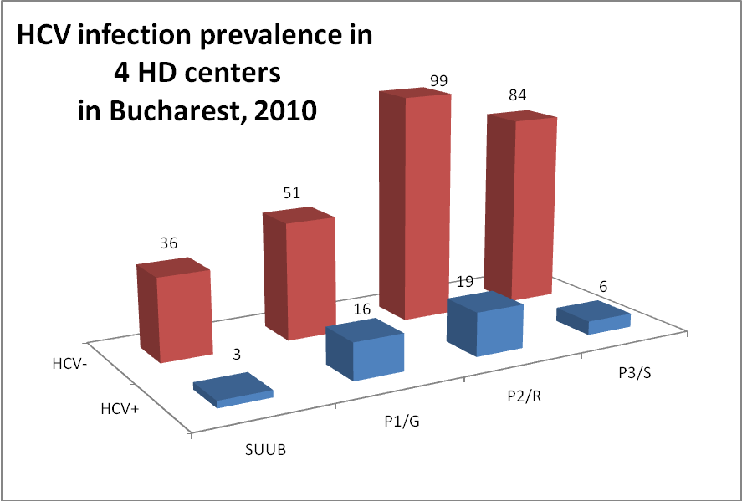

Conclusions

Hepatitis C in dialysis remains a major problem. Most likely strict adherence to universal precautions is an effective and sufficient strategy at sites with low prevalence such as ours, where no isolation measures are imposed. Further studies are needed at the centers with high prevalence such as the 3 Moldova counties where additional measures may be necessary.
HCV Infection occurs, as in the general population, at younger ages, of high socio-economic importance. For this reason, it is debatable whether any "good" influence of HCV infection on survival is not somehow actually only related to the younger age of onset, thus it is a confounding factor.
We suggest the need for anti-HBV vaccination programs specific to the (hemo) dialysis patients and not just through the Ministry of Health's general campaigns as required by current laws.

Received in April 2011, accepted in July 2011.

Seyed-Moayed Alavian, A shield against a monster: Hepatitis C in hemodialysis patients. World J Gastroenterol 2009 February 14; 15(6): 641-646
Rahnavardi M et al, Hepatitis C in Hemodialysis Patients: Current global Magnitude, natural History, Diagnostic Difficulties, and Preventing Measures. Am J Nephrol 2008; 28: 628-640
Jadoul M et al., Universal precautions prevent hepatitis C virus transmission: a 54 month follow-up of the Belgian Multicenter Study. The Universitaires Cliniques St-Luc (UCL) Collaborative Group. Kidney Int 1998, 53:1022-1025
Barril G et al., Decrease in hepatitis C virus (HCV) prevalence in hemodialysis patients in Spain: effect of time, initiating HCV prevalence studies and adoption of isolation measures. Antiviral Res 2003, 60:129-134
Taskapan H et al. Patient to patient transmission of hepatitis C virus in hemodialysis units. Clin Nephrol 2001, 55:477-481
Covic A et al. Hepatitis virus infection in haemodialysis patients from Moldavia. Nephrol Dial Transplant 1999; 14: 40-45
Iancu LS Hepatita postransfuzională acută în teritorioul Moldovei. Teză de doctorat, Universitatea de Medicină „Gr.T Popa” Iaşi, 1996
Kalantar-Zadeh K et al., Hepatitis C virus and death risk in hemodialysis patients. J Am Soc Nephrol 2007; 18: 1584-1593
El-Amin HH et al., Hepatitis C virus infection in hemodialysis patients in Sudan: two center’s report. I Saudi J Kidney Dis Transpl 2007; 18: 101-106
Hmaied F et al., Hepatitis C virus infection among dialysis patients in Tunisia: incidence and molecular evidence for nosocomial transmission. J Med Virol 2006; 78: 185-191
Ross RS et al. Lack of de novo hepatitis C virus infections and absence of nosocomial transmission of GB virus C in a large cohort of german haemodilysis patients. Journal of Viral Hepatitis 2009; 16: 230-238
Rahnavardi M et al, Hepatitis C in Hemodialysis Patients: Current global Magnitude, natural History, Diagnostic Difficulties, and Preventing Measures. Am J Nephrol 2008; 28: 628-640
Hardy NM et al. Antibody to hepatitis C virus increases with time on hemodialysis. Clin Nephrol 1992; 38: 44-48
Sypsa V et al, Incidence and patterns of hepatitis C virus seroconversion in a cohort of hemodialysis patients. Am J Kindney Dis 2005; 45: 334-343
Covic A et al. Hepatitis virus infection in haemodialysis patients from Moldavia. Nephrol Dial Transplant 1999; 14: 40-45
Amiri YM et al. Seroprevalence of hepatitis C and risk factors in haemodialysis patients in Guilan, Islamic Republic of Iran. East Mediterr Health J 2005; 11: 372-376
Hussein MM et al., The impact of polymerase chain reaction assays for the detection of hepatitis C virus infection in a hemodialysis unit. Saudi J Kidney Dis Transpl 2007; 18: 107-113
Saxena AK, Panthora BR: The susceptibility of patients with type-2 diabetes to hepatitis C virus infection during long-term haemodilysis Swiss med Wkly 2003; 133: 611-618
Ocak S et al., Seroprevalence of hepatitis C in patients with type 2 diabtes mellitus and non-diabetic on haemodialysis Int J Clin Pract 2006; 60: 670-674
Sahin I et al., Does hepatitis C virus infection increase hematocrit and hemoglobin levels in hemodialysed patients? Clin Nephrol 2003; 60: 401-404
Khurana A et al., Effect of hepatitis C inefction on anemia in hemodialysis patients Hemodialysis International 2008; 12: 94-99
Ross RS et al. Lack of de novo hepatitis C virus infections and absence of nosocomial transmission of GB virus C in a large cohort of german haemodilysis patients. Journal of Viral Hepatitis 2009; 16: 230-238
Chlabicz S et al, Known and probable risk factors for hepatitis C infection: A case-series in north-eastern Poland. World J Gastroenterol 2006; 12: 141-145
Jinghua S et al., Hepatitis C infection and related factors in hemodialysis patients in China: systematic review and meta-analysis.
Chlabicz S et al, Known and probable risk factors for hepatitis C infection: A case-series in north-eastern Poland. World J Gastroenterol 2006; 12: 141-145
Salama G et all, Hepatitis C virus infection in French hemodialysis units:a multicenter study. J Med Virol 2000; 61: 44-51
Sypsa V et al, Incidence and patterns of hepatitis C virus seroconversion in a cohort of hemodialysis patients. Am J Kindney Dis 2005; 45: 334-343
Covic A et al. Hepatitis virus infection in haemodialysis patients from Moldavia. Nephrol Dial Transplant 1999; 14: 40-45
Amiri ZM et al. Seroprevalence of hepatitis C and risk factors in haemodialysis patients in Guilan, Islamic Republic of Iran. East Mediterr Health J 2005; 11: 372-376
Campistol JM et al., Hepatitis C virus-positive patients on the waiting list for transplantation: study, evaluation and treatment. Nephrol Dial Transplant 2000; 15 [Suppl 8]: 68-70
Lopes EP et al., Determination of the cut-off value of serum alanine aminotransferase in patients undergoing hemodialysis to identify biochemical activity in patients with hepatitis C viremia J Clin Virol 2006; 35: 298-302
Barril G., Hepatitis C virus-induced liver disease in dialysis patients. Nephrol Dial Transplant 2000, 15 Suppl 8: 42-45
Saab S et al., Serum alanine aminotransferase in hepatitis C screening of patients on hemodialysis. Am J Kidney Dis 2001; 37: 308-315.
Mathurin P et al., Impact of hepatitis B and C virus on kidney transplantation outcome. Hepatology 1999, 29: 257-263
Stehman-Breen CO et al., Risk of deathamong chronic dialysis patients infected with hepatitis C virus. Am J Kidney Dis 1998, 32:629-634
Pereira BJ et al., Effects of hepatitis C infection and renal transplantation on survival in end-stage renal disease. The New England Organ Bank Hepatitis C Study Group. Kidney Int 1998, 53:1374-1381
Hanafusa T et al., Retrospective study on the impact of hepatitis C virus infection on kidney transplant patients over 20years. Transplantation 1998, 66:471-476
Lezaic V et al., Hepatitis B and hepatitis C virus infection and outcome of hemodialysis and kidney transplant patients Renal Failure 2008; 30: 81-87
Moe SM, Pamplone AJ, Ofner S et al, Association of Hepatitis C Virus Infection With Prevalence and Development of Kidney Disease, Am J Kidney Dis 2008; 51: 885-892.
Hosseini-Moghaddam SM et al., distribution of hepatitis C virus genotypes among hemodialysis patients in Tehran- a multicenter study. J Med Virol 2006; 78: 569-573
Petrosillo N et al, Prevalence of infected patients and understaffing have a role in hepatitis C virus transmission in dialysis. Am J Kidney Dis 2001;37: 1004-1010
Carneiro MA et al., Hepatitis C prevalence and risk factors in hemodialysis patients in Central Brazil: a survey by polymerase chain reaction and serological methods. Mem Inst Oswaldo Cruz 2001; 96: 765-769
Fissell RB et al. Patterns of hepatitis C prevalence and seroconversion in hemodialysis units from three continents: The DOPPS. Kidney Int 2004, 65:2335-2342
Hmaied F et al., Hepatitis C virus infection among dialysis patients in Tunisia: incidence and molecular evidence for nosocomial transmission. J Med Virol 2006; 78: 185-191
Anexa la Ordinul MS 1718/2004 privind aprobarea Regulamentului de organizare şi funcţionare a unităţilor de dializă publice şi private, Monitorul Oficial al României anul 173 (XVII) – NR 233 BIS, 2005
Jinghua S et al., Hepatitis C infection and related factors in hemodialysis patients in China: systematic review and meta-analysis.
Izopet J et al., Incidence of HCV infection in French hemodialysis units: a prospective study. J Med Virol 2005, 77:70-76
Vlăduţiu DS et al., Infections with hepatitis B and C viruses in patients on maintenance dialysis in Romania and in former communist countries: yellow spots on a blank map? J Viral Hepat 2000; 7: 313-319

