ANATOMICAL CORONARY ARTERY ANOMALIES AND RISK FACTORS WITH NEGATIVE PROGNOSIS IN CARDIOVASCULAR ALTERATION

Cezara-Elena Răileanu^{1,3}, Igor Nedelciuc¹, Liviu Macovei^{1,2}, Gabriela Omete¹, Cătălina Arsenescu Georgescu^{1,2}
¹ “Prof. Dr. George I.M. GEORGESCU” Institute of Cardiovascular Diseases
Iaşi
² UMF „Gr. T. Popa” Iaşi
³ doctorand al UMF „Gr. T. Popa” Iaşi
Correspondence address:

Dr. Răileanu Cezara-Elena
“Prof. Dr. George I.M. GEORGESCU”Institute of Cardiovascular Diseases
Bd. Carol I nr. 50, 700503 - Iaşi
e-mail: cezarae@hotmail.com

Abstract
Introduction. Anatomical coronary artery anomalies represent a rare cardiovascular pathology, with poor reference in the specialized literature. Through their own physiopathologic mechanisms, these anomalies can generate phenomena of myocardial ischemia, even in the absence of associated atherosclerotic lesions. The clinical manifestations are diverse, depending to a large extent on the hemodynamic impact created, but also on the risk factors with negative prognosis in cardiovascular alteration.

Material and method. The research is based on the study of 8,772 coronarographies, covering a period of approximately 8 years, at the „Prof. Dr. George I.M. Georgescu” Institute of Cardiovascular Diseases, Iaşi, on patients with coronary history, proved clinically or paraclinically, as well as on patients under pre-surgery preparations for various pathologies. The anatomical coronary artery anomalies identified were subsequently processed to establish an angiographic incidence, the manifestation possibilities as well as the rate of association with the various risk factors in the cardiovascular alteration. The risk factors with negative prognosis selected were the factors highly prevalent among the general population: dysplidaemias, essential hypertension, diabetes mellitus. Results. 159 cases of anatomical coronary artery anomalies were identified (angiographic incidence of 1.81%), of which:13.20% coronary fistulas, 27.60% emergence anomalies, 49.68% muscular bridges, 9.43% coronary aneurysms. The main clinical manifestation was the angina pectoris (52.2%). Their rate of association with the proposed risk factors was the following: dysplidaemias – 57.4%, hypertension – 37.7%, diabetes mellitus – 17%.

Conclusions. Anatomical coronary artery anomalies represent a rare cardiovascular alteration, with varied potential of manifestation, able to generate myocardial ischemia. The association with the risk factors proposed (though random) could aggravate the symptoms.
Keywords: anatomical coronary artery anomalies, myocardial ischemia, risk factors.

Introduction

Anatomical coronary artery anomalies represent a rare cardiovascular pathology, with poor reference in the specialized literature. According to the existing data, it can be stated that a population prevalence of approximately 0.2 – 2% was recorded; however, most of the anomalies remain asymptomatic or undiagnosed, probably also due to the limitations imposed on invasive procedures.
Through its own physiopathological mechanisms, this entity can generate phenomena of myocardial ischemia, even in the absence of associated atherosclerotic lesions. The clinical manifestations are diverse, depending to a large extent on the hemodynamic impact created, but also on the risk factors with negative prognosis in cardiovascular alteration.

Objectives of the Study

The present study intends to approach anatomical coronary artery anomalies from the angiographic as well as from the clinical viewpoint, in order to achieve deeper knowledge of this rare form of cardiovascular alteration.
To this end, the study includes all the anatomical coronary artery anomalies identified angiographically during a period of 8 years. The majority of the cases were considered minor cases in the specialized literature, anomalies with low hemodynamic impact and varying clinical manifestations. This is caused by the lethal potential of the major coronary artery anomalies, which are harder to detect angiographically as more accurate data are obtained from necroptic studies.
Although there are controversies in the literature on the categorization of myocardial bridges in the class of minor coronary artery anomalies, we preferred to approach them in this study based on the perspective opened by the physiopathological mechanism of the myocardial ischemia, as well as on the data provided by the specialized literature, which determine the lethal potential. Moreover, the cases selected for the present study are only the cases with mainly ischemic clinical manifestations and which, from the angiographic viewpoint, exerted a systolic compression of minimum 40%, thus infirming the anatomical version of the normal.
Each entity covered in the study presents its own physiopathological mechanisms of generating the myocardial ischemia, the association with the atherosclerotic disease aggravating the symptomatology. Due to the fact that the clinical manifestations are extremely diverse, it can be asserted that the association with other risk factors in the cardiovascular alteration has a high influence on the symptomatology.
From the risk factors with negative prognosis, certain pathologies with high prevalence among the general population were randomly selected, in order to objectivize their rate of association with the anatomical coronary artery anomalies.

Material and Method

Due to the rarity of this cardiovascular pathology, we have elaborated an extended study, covering 8,772 diagnostic coronarographies performed during a period of approximately 8 years (2003-2010), at the „Prof. Dr. George I.M. Georgescu” Institute of Cardiovascular Diseases, Iaşi, on patients with coronary history, proved clinically or paraclinically, as well as on patients under pre-surgery preparations for other cardiovascular pathologies, in order to determine a population prevalence close to the data in the literature.
The anatomical coronary artery anomalies identified were subsequently processed to establish an angiographic incidence, the manifestation possibilities as well as the rate of association with the various risk factors with negative prognosis in the cardiovascular alteration.
The pathologic entities covered in this study were the following: coronary fistulas, anatomical anomalies of coronary emergence, myocardial bridges and coronary aneurysms. From the risk factors with negative prognosis, the ones with high prevalence among the general population were randomly selected: dysplidaemias, essential hypertension, and diabetes mellitus

Results and Discussions

Following the study elaborated on the set of 8,772 coronarographies, 159 cases of anatomical coronary artery anomalies were objectivized. The angiographic incidence recorded was of 1.81%, which meets the data existing in the literature.
Among the 159 subjects with this pathology the following cases were explored: 21 cases of coronary fistulas (13.20%), 44 cases of anatomical anomalies of coronary emergence (27.60%), of which the prevalence was represented by the origin of LCX from RCA (18 cases), 79 cases of muscular bridges (49.68%) and 15 cases of coronary aneurysms (9.43%) (Figure no. 1). Most of the anatomical anomalies studied were minor anomalies.
The general symptomatology recorded in the cases of anatomical coronary artery anomalies highlighted mainly the angina pectoris (52.2%) and the heart failure (24.5%). The polymorphic clinical manifestations were noticed in 23.3% of the cases.
The statistically significant prevalence of the angina pectoris in the batch of 159 is another argument of the fact that anatomical coronary artery anomalies generate manifested myocardial ischemia, both through their own mechanisms and as adjuvants for the atherosclerotic disease.
From the viewpoint of association with the risk factors with negative prognosis selected for the present study, the presence of dysplidaemias is noticed in 54.7% of the cases, hypertension being encountered in 37.7% of the cases and diabetes mellitus in 17% of the cases.
The distribution of association with dysplidaemia per casuistry was not homogenous from the statistical viewpoint. In the studied casuistry, the distribution of cases of dysplidaemia was more frequent in the cases with anomalies on the muscular bridges (25.2%) and the emergence anomalies (16.4%); however, from the statistical viewpoint, these distributions were not significant (χ²=1.78; GL=3; p=0.619). Per each type of anomalies, the following aspects were noticed: in 40/79 the cases with myocardial bridges there was also dysplidaemia (50.6%); in 26/44 (59.1%) cases with emergence anomalies dysplidaemia was also present; in the case of patients with fistulas, 11/21 cases with dysplidaemia (52.4%) were recorded; coronary aneurysm was associated with dysplidaemia in 10/15 cases (66.7%) (Figure no. 2).
The correlation matrix confirms that the number of dysplidaemias has not increased significantly depending on the anomalies. In conclusion, the presence of dysplidaemias varied from 50% to 70%, irrespective of the type of anatomical coronary artery anomaly.
The percentage of statistical significance (37.73%) of the essential hypertension in the batch of 159 subjects used for this research can be explained by the fact that this type of pathology represents one of the most common forms of cardiovascular alteration among the general population. In the studied casuistry, the distribution of the cases of hypertension was more frequent in the cases with myocardial bridge anomaly (19.5%) and in the emergence anomalies (10.1%); however, from the statistical viewpoint, these distributions were not significant (χ²=0.24; GL=3; p=0.972). Per types of anomalies, the following distributions were noticed: 31/79 cases of hypertension and anomaly of the myocardial bridges (39.2%); 16/44 (36.4%) cases with anatomical anomalies of coronary emergence were associated with hypertension; in the case of patients with coronary fistulas, 8/21 cases with hypertension were recorded (38.1%); coronary aneurysm was associated with hypertension in 5/15 cases (33.3%) (Figure no. 3).
The correlation matrix confirms statistically that the number of number of essential hypertension cases has not increased has not increased significantly, by comparison to the types of anomalies. In conclusion, hypertension is present in approximately 30-40% of the cases, in all the types of anatomical coronary artery anomalies identified.
Although we can notice the difference between the percentage of association of hypertension and the association of diabetes mellitus, taking into account the fact that both pathologies are highly prevalent among the general population with cardiovascular diseases, it can be asserted that the association of diabetes mellitus with anatomical coronary artery anomalies had a statistically significant prevalence.
The distribution of association with diabetes mellitus per casuistry was not homogenous from the statistical viewpoint. The lack of distribution equality among the reports of association of diabetes mellitus with various types of anatomical coronary artery anomalies amongst the 159 subjects included in this study is purely random and insignificant from the statistical viewpoint, as the phenomenon can also be explained by the inequality amongst the various subgroups of studied anomalies.
In the studied casuistry, the distribution of the cases of diabetes mellitus was more frequent in the cases with myocardial bridge anomaly (10.1%) and fistulas (3.1%); however, from the statistical viewpoint, these distributions were not significant (χ²=3,38; GL=3; p=0,337). Per types of anomalies, the following distributions were noticed: 16/79 cases with myocardial bridges (20.3%); 4/44 cases with emergence anomalies (9.1%) were associated with diabetes mellitus; on patients with fistulas, 5/21 cases (23.8%) of diabetes mellitus were recorded; the aneurysm was associated with diabetes mellitus in 2/15 cases (13.3%) (Figure no. 4).
The correlation matrix confirms that the number of diabetes mellitus has not increased significantly depending on the anomalies. In conclusion, diabetes mellitus was identified only in approximately 10 – 20% of the cases with anatomical coronary artery anomalies, irrespective of the type of anomaly.
Taking into account the physiopathological mechanisms of the endothelial dysfunction, as well as the increasing prevalence among the general population, it can be asserted that diabetes mellitus contributes to the occurrence of the atherosclerotic disease and, thus, to the triggering of the myocardial ischemia mechanisms.
Although in the present case, the association made with the anatomical coronary artery anomalies is purely random and not causative, diabetes mellitus can represent a risk factor with negative prognosis in the present study.

Conclusions

Anatomical coronary artery anomalies represent a subject which continues to raise questions, stirring the interest of researchers both due to its rarity and insufficient knowledge and due to the reduced diagnosis possibilities in the modern medical practice, as well as due to the polymorph symptomatology (often subjective) which they can generate.
The statistically significant prevalence of the angina pectoris in the batch of 159 is another argument of the fact that anatomical coronary artery anomalies generate manifested myocardial ischemia, both through their own mechanisms and as adjuvants for the atherosclerotic disease.
It has to be mentioned that the risk factors with negative prognosis selected for this study, in association with the anatomical coronary artery anomalies present, firstly, a purely random causality relationship, being selected both on the basis of the high prevalence among the general population and on the basis of their mechanisms of each entity, used to generate the phenomena of myocardial ischemia or of heart failure.
The anatomical coronary artery anomalies represent a rare cardiovascular pathology, with poor reference in the medical practice. Taking into account the data existing so far in the specialized literature, the present study envisaged determining and argumenting new reference points useful for the approach and complex investigation of this entity.

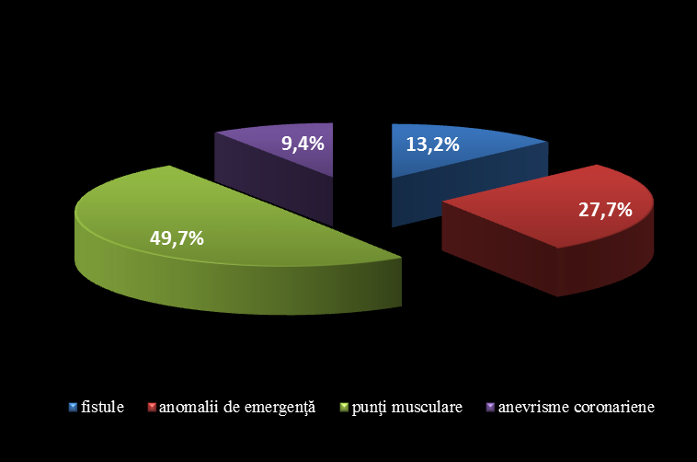
Figure no.1. Distribution of cases per types of anatomical coronary artery anomalies

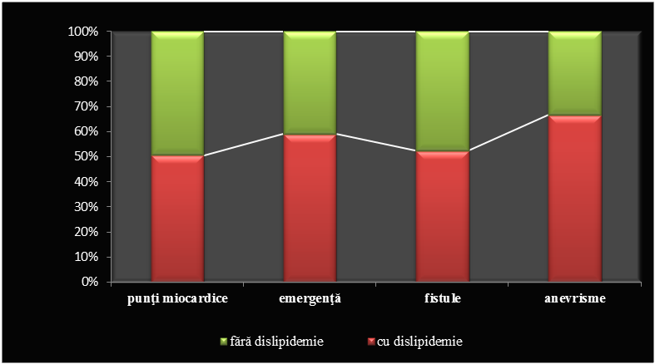
Figure no.2. Volume of dysplidaemias in the total of anatomical coronary artery anomalies

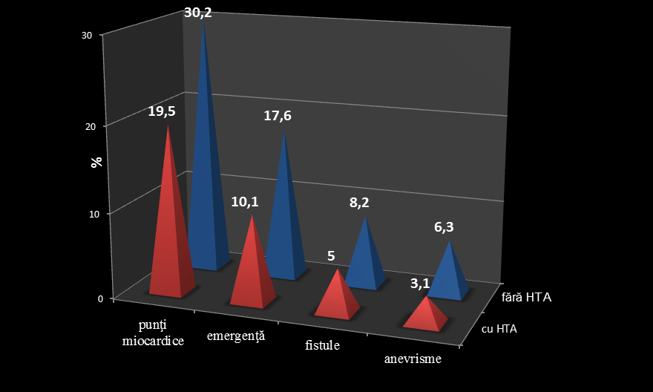
Figure no. 3. Distribution of hypertension cases, depending on the type of anatomical coronary artery anomalies

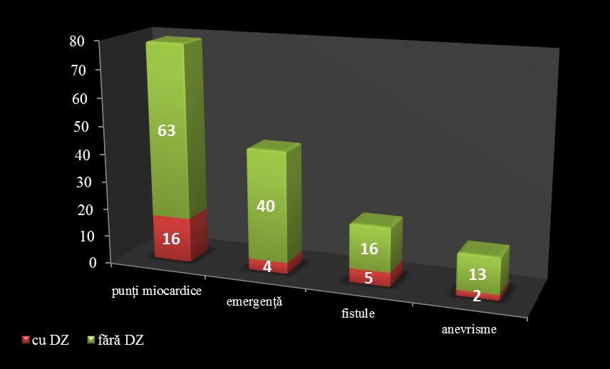
Figure no.4. Volume of diabetes mellitus cases in the total of anatomical coronary artery anomalies

Bibliography
- Chiriac M., Zamfir M., Antohe D. Anatomia trunchiului (Anatomy of the Torso). Vol.1, Ed. UMF „GR.T.POPA” Iasi, 1995;
- Onciu M. Aspecte morfo-funcţionale ale vascularizaţiei miocardului şi ale aparatului său valvular din moartea subită cardiacă (Morphofunctional Aspects of the Myocardium Vascularisation and of its Valve Apparatus in Sudden Death Caused by Cardiac Arrest). teză de doctorat, UMF GR. T. POPA Iaşi, 2003;
- Georgescu G.I.M., Arsenescu C. Tratamentul raţional al bolilor cardiovasculare majore. (Rational Treatment of Major Cardiovascular Diseases) Ed. Polirom, 2001;
- Răileanu C.E., Nedelciuc I., Briotă L. şi colab. Anomaliile antomice coronariene – cauză de angină pectorală non–aterosclerotică. (Anatomical Coronary Artery Anomalies – Cause of Non-atherosclerotic Angina Pectoris) Revista Română de Cardiologie Vol. XXIV, Nr.1, 2009, pag 5-7;
- Alexander RW, Griffith GC. Anomalies of the coronary arteries and their clinical significance. Circulation 14, 5, 1956;
- Zeppilli P., Dello Russo A., Santini C. și colab. In vivo detection ot coronary artery anomalies in asymptomatic athletes by echocardiographic screening. Chest, 1998 Jul, 114: 1, 89-93;
- Frescura C., Basso C., Thiene G. şi colab. Anomalous origin of coronary arteries and risk of sudden death: a study based on an autopsy population of congenital heart disease. Hum Pathol, 1998 Jul, 29: 7, 689-95;
- Isomatsu Y., Imai Y., et al. Surgical intervention for anomalous origin of the left coronary artery from the pulmonary artery: the Tokyo experience. J Thorac Cardiovasc Surg 2001;121:792-797;
- Lytrivi I.D., Wong A.H, Ko H.H. şi1 colab. Echocardiographic diagnosis of clinically silent congenital coronary arteriy anomalies. International Journal of Cardiology, Vol. 126, nr.3, pag 386-393, 2008;
- Dodge-Khatami A., Mavroudis C. and Becker C.L. Congenital Heart Surgery Nomenclature and Database Project: anomalies of the coronary arteries. The Annals of Thoracic Surgery, Vol. 69, nr. 3, pag. 270-297, 2000;

Received in May 2011, accepted in July 2011.

