ULTRASOUND SCREENING OF VASCULAR ENDOTHELIUM AND LEFT VENTRICULAR DIASTOLIC DYSFUNCTION IN THE ASSESSMENT OF CARDIOVASCULAR RISK IN TYPE 2 DIABETES MELLITUS

Alice Bălăceanu, Horia Bălan
University of Medicine and Pharmacy ”Carol Davila”, Bucharest,
Emergency Ilfov County Hospital, Internal Medicine Department
e-mail: alicebalaceanu@yahoo.com

Abstract
Background. Endothelial dysfunction is a systemic process who appear in the coronary circulation as in the systemic circulation. Carotid intima media thickness (IMTc) and brachial artery flow-mediated dilation (FMD) are affected in diabetes mellitus, as markers of atherosclerotic cardiovascular disease risk.
The aim of the study was to describe the association between carotid intima media thickness (IMTc), altered brachial artery flow mediated dilation (FMD) and left ventricular diastolic dysfunction to the women with type 2 diabetes mellitus.
Materials and Methods. This was a prospective study of 54 female patients with type 2 diabetes mellitus hospitalized in the Internal Department of Ilfov Emergency Hospital between 1st of January 2010 and 31st of June 2010.
Results. The patients were aged between 48 and 69 (mean age 62). The risk factors for arterial atherosclerotic disease were: type 2 diabetes mellitus, hyperlipidaemia, obesity. Exclusion criteria were: smoke, hypertension, clinical cardiovascular disease (coronary artery disease or stroke), valve disease, end-stage renal disease.
IMTc varied between 8.32 mm and 1.14 mm and the plaque prevalence was 72%. All the patients had affected FMD, with an average value of 7.4%, and left ventricular diastolic dysfunction with pattern of delayed relaxation in 88.88% of cases and pseudonormal in 11.12% of cases.
Conclusions. The effect of type 2 diabetes mellitus on early atherosclerosis in women is very pronounced, especially in postmenopausal women. Screening for IMTc, FMD and left ventricular diastolic dysfunction might be beneficial for assessment of future atherosclerotic complications of diabetes mellitus.
Keywords: type 2 diabetes mellitus, IMTc, FMD, left ventricular diastolic dysfunction

Introducere. Disfuncţia endotelială este un proces sistemic generalizat, apărând atât în circulatia coronară cât şi în cea sistemică. Grosimea intimă-medie carotidiană (IMTc) şi vasodilataţia mediată de flux a arterei brahiale (FMD) sunt afectate în diabetul zaharat, fiind markeri ai riscului de boală cardiovasculară aterosclerotică.
Scopul lucrării: descrierea asocierii dintre IMTc, FMD şi disfuncţia diastolică de ventricul stâng la pacientele diabetice.
Material şi metodă. Studiu prospectiv pe un lot de 54 paciente cu diagnosticul de diabet zaharat tip 2, internate în Spitalul Judeţean Ilfov, Clinica Medicală, în perioada 1.ianuarie – 30.iunie.2010.
Rezultate. Pacientele au avut vârste cuprinse între 48 şi 69 ani (vârsta medie 62 ani). Factorii de risc pentru boală arterială aterosclerotică: diabet zaharat tip 2, dislipidemie, obezitate. Criterii de excludere din lot: fumatul, HTA, boala cardiovasculara clinic manifestă (boala coronariană sau AVC), valvulopatii, boală renală terminală. IMTc a variat între 8,32 mm şi 1.14 mm şi prevalenţa plăcii a fost de 72%. Toate pacientele au avut afectarea FMD cu o valoare medie de 7.4% şi disfuncţie diastolică de ventricul stâng, tip relaxare întârziată la 88.88%, pseudonormal la 11.12%.
Concluzii. Efectul diabetului zaharat tip 2 pe ateroscleroza timpurie la femei este foarte pronunţat, în special după menopauză. Screening-ul IMTc şi FMD la pacientele diabetice este benefic pentru evaluarea riscului cardiovascular.
Cuvinte cheie: diabet zaharat tip 2, IMTc, FMD, disfuncţie diastolică de ventricul stâng

Introduction

Type 2 diabetes mellitus is being considered as a pandemic disease. Cardiovascular disease is the major cause of morbidity and mortality in type 2 diabetes mellitus, due to arterial structure and functional changes.(1) Initially considered as a semipermeable barrier separating lumen from vessel wall, the endothelium is now recognised as a complex endocrine organ responsible for a variety of physiological processes vital for vascular homeostasis.(2) These include the regulation of vascular tone, luminal diameter, and blood flow; hemostasis and thrombolysis; platelet and leucocyte vessel-wall interaction; the regulation of vascular permeability, and tissue growth and remodelling.(2) The endothelium modulates arterial stiffness, wich precedes overt atherosclerosis and is an independent predictor of cardiovascular events.(2)
Ultrasound is widely used to evaluate atherosclerosis, for the assessment the risk of cardiovascular disease in healthy persons and in persons with cardiovascular risk factors. (3) Three markers of vascular disease may help to a better evaluation of vascular dysfunction in type 2 diabetes mellitus patients: carotid intima-media thickness (IMTc), arterial stiffness, assessed by pulse wave velocity (PWV), and endothelial function, evaluated through the brachial artery flow-mediated dilation (FMD). (1,4,5,6) Among these parameters, IMTc is considered a marker of structural vessel wall properties, and arterial stiffness reflects functional wall properties. Endothelial dysfunction is a systemic process who appear in the coronary circulation as in the systemic circulation. IMTc and brachial artery FMD are affected in diabetes mellitus, and they are risk marker of atherosclerotic cardiovascular disease. IMTc is incresed in patients with type 2 diabetes mellitus and other independent risk factors, such as: age, hyperlipidaemia, and duration of diabetes mellitus. The patients with diabetes mellitus have shown increased arterial stiffness, with reductions in FMD wich has already been reported to be inversely and strongly related to the extent of hyperglycemia.(1)
In the early stage of atherosclerosis, the functional parameters, as FMD are helpful in the assessment of cardiovascular risk to the patients with cardiovascular risk factors. (7,8,9,10) The increased IMTc and the altered FMD are related with the presence and the degree of coronary atherosclerosis.(11,12)

Aim of study

The aim of the study was to describe the association between carotid intima media thickness (IMTc), altered brachial artery flow mediated dilation (FMD) and left ventricular diastolic dysfunction to the women with type 2 diabetes mellitus.

Materials and Methods

This was a prospective study of 54 female patients with type 2 diabetes mellitus hospitalized in the Internal Department of Ilfov Emergency Hospital between 1st of January 2010 and 31st of June 2010. All the patients had physical examination, blood tests, lipid profile, C-reactive protein, ECG, chest radiography, carotid and brachial arteries ultrasound, cardiac ultrasound. Exclusion criteria were: smoke, hypertension, clinical cardiovascular disease (coronary artery disease or stroke), valve disease, end-stage renal disease.
IMTc was calculated as the distance from the media-adventitia interface to the intima-lumen interface on the far wall, between the carotid bulb origin and a point 10 mm proximal to the CCA on the longitudinal view. It was considered the mean IMT value on the left and right CCA. (2,4,13,14)
Measurements of the right brachial artery was taken at rest after lying quietly for at least 10 min, and no smoke, food or caffeine 4 hours before. The right brachial artery was imaged, 5-10 cm above the antecubital fossa, with a 10 MHz ultrasound probe. Brachial artery FMD was induced by a 5 min inflation of a pneumatic cuff placed around the forearm, immediately below the antecubital fossa, to 250 mm Hg, followed by rapid deflation. Diameter measurements were taken from one media-adventitia interface to the other in the longitudinal view, at baseline and for at least three times after reactive hyperemia, one of them at 60s after deflation. FMD was expressed as a maximal percentage change in vessel diameter from the baseline (D max – D baseline /D baseline x100). The profile of the flow velocity was registered at rest and at 15s after cuff deflation, as the systolic and diastolic velocity, as the original method described by Celermajer(15) and subsequently standardized.(16)
The assessment of left ventricular diastolic function was done by the Doppler trace of mitral inflow, with evaluation of peak E velocity, peak A velocity, E/A ratio, A wave duration, deceleration time, isovolumic ventricular relaxation time, left atrial and ventricular dimensions, pulmonary vein flow, and Valsalva manoeuvre for the pseudonormal pattern of diastolic dysfunction. (17)

Results

The patients were aged between 48 and 69 (mean age 62). The risk factors for arterial atherosclerotic disease were: type 2 diabetes mellitus, hyperlipidemia, obesity.
IMTc varied between 8.32 mm and 1.14 mm and the plaque prevalence was 72%. (Fig. 1) All the patients had affected FMD, between 2.9% and 8.5%, with an average value of 7.4%.(Fig. 2) As the same fact all the patients had left ventricular diastolic dysfunction, with pattern of delayed relaxation in 88.88% of cases (Fig. 3), pseudonormal in 11.12% of cases (Fig.4a) For the patients with pseudonormal pattern, Valsalva manoeuvre revealed a new ratio E/A <1 (Fig.4b)
Limitations of the study: small number of patients, without statistical significance, no evaluation of myocardial velocity by tissue Doppler, no automatic calculation of vascular indices.

Discussions

Cardiovascular disease is the major cause of mortality in type 2 diabetes mellitus. Type 2 diabetes mellitus is associated with endothelial dysfunction. The underlying mechanisms are suspected to be related to hyperglycaemia and insulin resistance, wich results in mitochondrial superoxide overproduction, with decreased NO availability. Clustering of risk factors such as dislipidaemia, hypertension and obesity in the metabolic syndrome play an additional role. (18) In our study the group comprised a small number of patients, because the majority of the patients with type 2 diabetes mellitus, hospitalised in our clinic had multiple cardiovascular risk factors, especially hypertension and smoke, with a great prevalence of the metabolic syndrome. At least in the hospital it is difficult to find patients only with diabetes mellitus, so this was one reson for which we choosed female patients with type 2 diabetes meliitus, non-smokers, no hypertensive.
Insulin-mediated vasodilatation is at least in part NO-dependent, thus explaining how insulin resistance may cause endothelial dysfunction.(18) The predictive value of endothelial dysfunction in epicardial coronary arteries of diabetic patients has been established for long- term coronary events. (19) Mean common IMTc in middle-aged individuals is reported to range from 0.71-0.98 mm in diabetic patients vs 0.66-0.85 mm in controls.(18) In our study the mean value of IMTc corresponded with literature data.
FMD ranges from about 10% in young adults to 0% in patients with established coronary heart disease, and it has proven to be predictive for the presence of coronary heart disease and for future coronary events in high-risk population.(18)
The myocardial dysfunction in diabetes mellitus and metabolic syndrome is characterised predominantly by diastolic consisting of relaxation abnormalities that are prevalent and have prognostic importance.(17,20,21) In our study all the patients had a degree of left ventricular diastolic dysfunction measured by conventional echocardiography, but the literature data showed that tissue Doppler imaging has the potential to meet the present need for a tool that can establish therapeutic efficacy in future preventive studies of insulin-resistance, diabetes and cardiovascular disease.(17)

Conclusions

The effect of type 2 diabetes mellitus on early atherosclerosis in women is very pronounced, especially in postmenopausal women. Screening for IMTc, FMD and left ventricular diastolic dysfunction might be beneficial for assessment of future atherosclerotic complications of diabetes mellitus.

References
- Christen AC, Armentano RL, Mirando A, et al. Arterial wall structure and dynamics in type 2 diabetes mellitus methodological aspect and pathophysiological findings. Curr Diabetes Rev 2010; 6(6): 367-77
- Lane HA, Smith JC, and Davies JS. Noninvasive Assessment of Preclinical Atherosclerosis. Vasc Health Risk Manag 2006; 2(1): 19-30
- Watanabe K, Oba K, Suzuki T, et al. The importance of assessment of endothelial function according to the time course of flow-mediated dilation of the brachial artery. J Nippon Med Sch 2010; 77(1):59-61
- Al-Qaisi Mo, Kharbanda RK, Mital TK, and Donald DE. Measurement of endothelial function and its clinical utility for cardiovascular risk. Vasc Health Risk Manag 2008; 4(3): 647-652
- Esper R, Nordaby RA, Vilarino JO, et al. Endothelial dysfunction: a comprehensive appraisal. Cardiovasc Diabetol 2006; 5:4
- Deanfield JE, Halcox JP, Rabelink TJ. Endothelial Function and Dysfunction. Testing and clinical relevance. Circulation 2007;115:1285-1295
- Gokce N, Keaney F, Hunter LM, et al. Risk stratification for postoperative cardiovascular events via noninvasive assessment of endothelial function: a prospective study. Circulation 2002; 105:1567-1570
- Brevetti G, Silvestro A, Schiano V, Chiarello M. Endothelial dysfunction and cardiovascular risk prediction in peripheral arterial disease: additive value of flow-mediated dilation to the ankle-brachial index. Circulation 2003; 108:2093-2098
- Bampi ABA, Rochitte CE, Favarato D, et al. Comparison of non-invasive methods for the detection of coronary atherosclerosis. Clinics (Sao Paolo) 2009: 67(7): 675-682
- Charakida M, Masi S, Lüscher T, et al. Assessment of atherosclerosis: the role of flow-mediated dilatation. Eur Heart J 2010; 31(23): 2854-2861
- Arsenescu I, Jurcut R, Deleanu D, et al. Grosimea complexului intima-media carotidiana si vasodilatatia mediate de flux a arterei brahiale la pacientii cu angina pectorala. Revista Romana de Cardiologie 2010; 25(1): 1-7
- Matsushima Y, Takase B, Uehata A, et al. Comparative predictive and diagnostic value of flow-mediated vasodilatation in the brachial artery and intima media thickness of the carotid artery for assessment of coronary artery disease severity. Int J Cardiol 2007; 117:165-72
- Allen Adolphe, Linda S Cook, Xun Huang. A Cross-sectional Study of Intima-Media Thickness, Ethnicity, Metabolic Syndrome, and Cardiovascular Risk in 2268 Study Participants. Mayo Clinic Proc. 2009; 84(3): 221-228
- Iannuzzi A, De Michele M, Bond MG et all. Carotid artery remodeling in middle-aged women with the metabolic syndrome (from “Progetto ATENA” Study). Am J Cardiol 2005; 96(8): 1162-5
- Celermajer DS, Sorensen KE, Gooch VM, et al. Non-invasive detection of endothelial dysfunction in children and adults at risk of atherosclerosis. Lancet 1992; 340(8828):1111-5
- Correti MC, Anderson TJ, Benjamin EJ, et al. Guidelines for the ultrasound assessment of endothelial-dependent flow-mediated vasodilatation of the brachial artery: a report of the International Brachial Artery Reactivity Task Force. J Am Coll Cardiol 2002; 39:257-265
- von Bibra H, Sutton M StJ. Diastolic dysfunction in diabetes and the metabolic syndrome: promising potential for diagnosis and prognosis. Diabetologia 2010; 53(6): 1033-1045
- Djaberi R, Beishuizen ED, Pereira AM, et al. Non-invasive cardiac imaging techniques and vascular tools for the assessment of cardiovascular disease in type 2 diabetes mellitus. Diabetologia 2008; 51(9):1581-1593
- Nitenberg A, Pham I, Antony I, et al. Cardiovascular outcome of patients with abnormal vasomotion and normal coronary arteriography is worse in type 2 diabetes mellitus than in arterial hypertension: a 10 years follow-up study. Atherosclerosis 2005; 183:113-120
- A Bălăceanu, A Sopa, C Diaconu, E Ionescu. Left ventricular diastolic dysfunction: ultrasound evaluation in diabetes patients. Revista medico- chirurgicală a Societaţii de medici şi naturalişti din Iaşi, 2007, vol III(4): 922-924
- Alice Bălăceanu. Ultrasound screening of intima-media thickness, left ventricular diastolic dysfunction and hepatic steatosis to the middle-aged women with metabolic syndrome. Archives of the Balkan Medical Union, 2011, vol 46(2):98-101

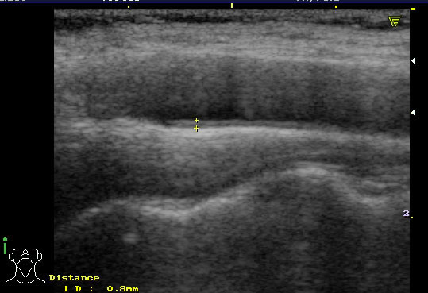
Figure1. Ultrasound longitudinal view to the level of common carotid artery, with calculation of IMT

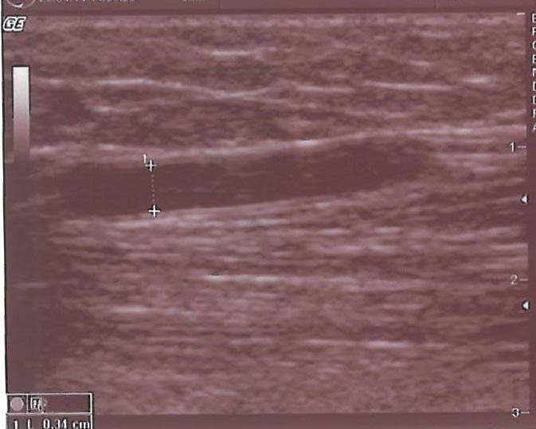
Figure 2. Ultrasound longitudinal view to the level of brachial artery, above the antecubital fossa, with calculation of diameter

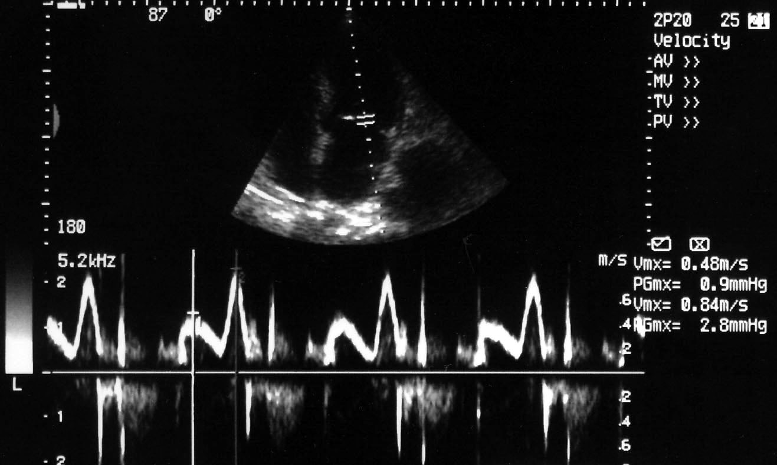
Figure 3. Pulsed Doppler in an apical 4-chamber view with pattern of delayed relaxation (E/A<1)

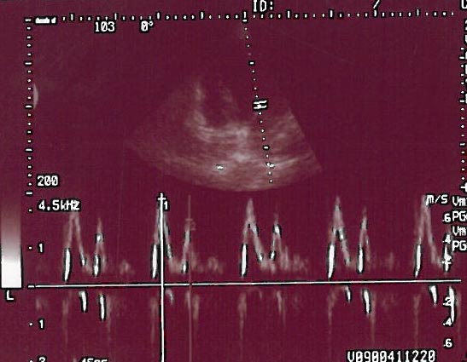
Figure 4a. Pulsed Doppler in an apical 4-chamber view with pseudonormal pattern (E/A>1)

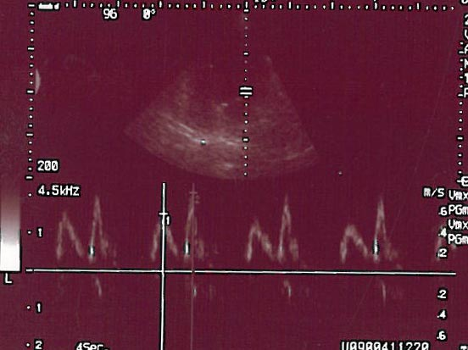
Figure 4b. Pulsed Doppler in an apical 4-chamber view with pseudonormal pattern; Valsalva manoeuvre decreased E wave (transformed in E/A<1)

